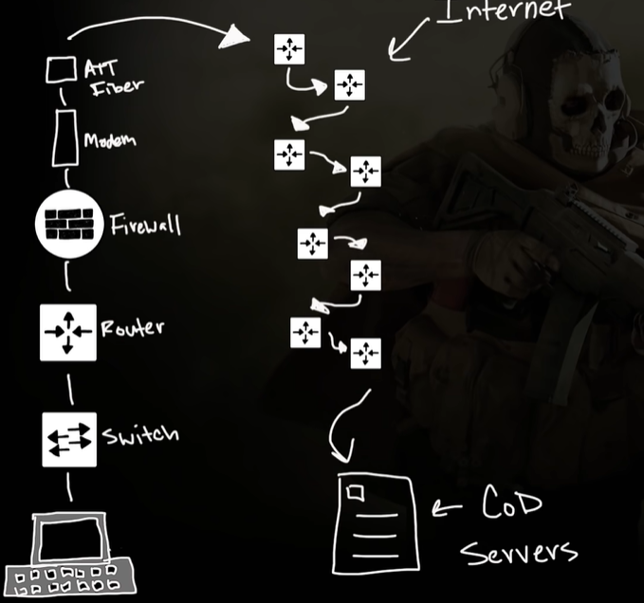

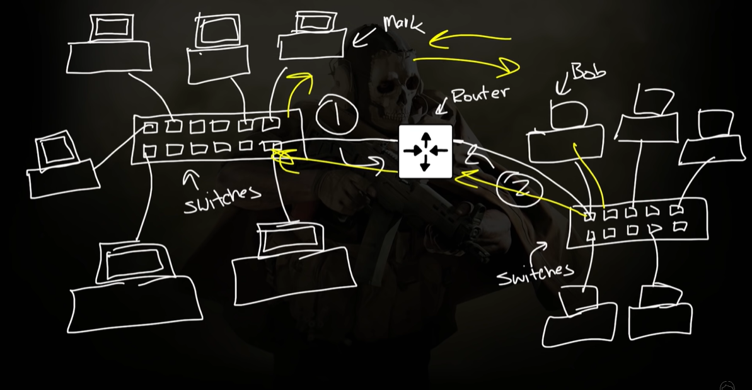

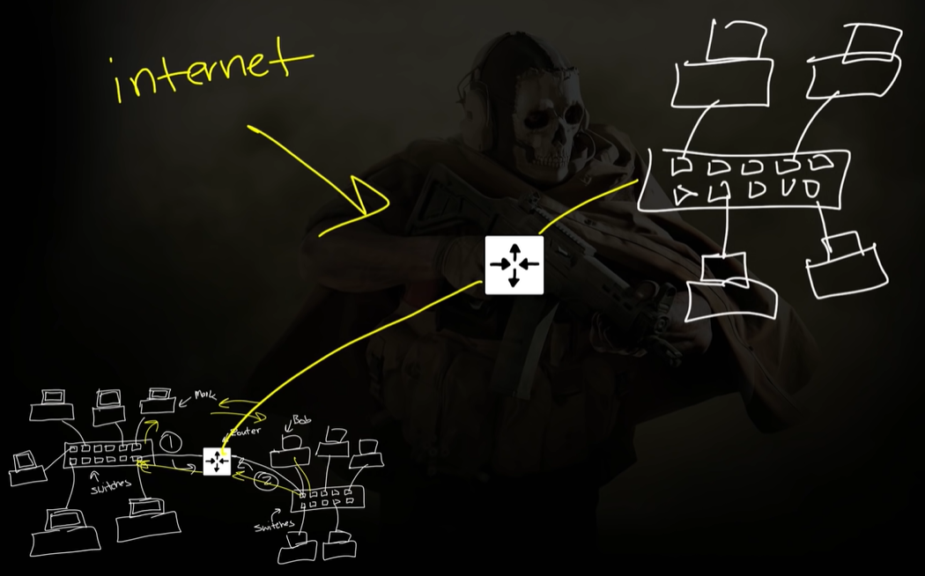

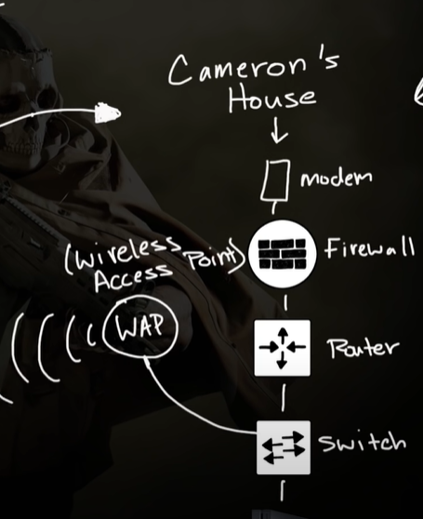

***what is a SWITCH?***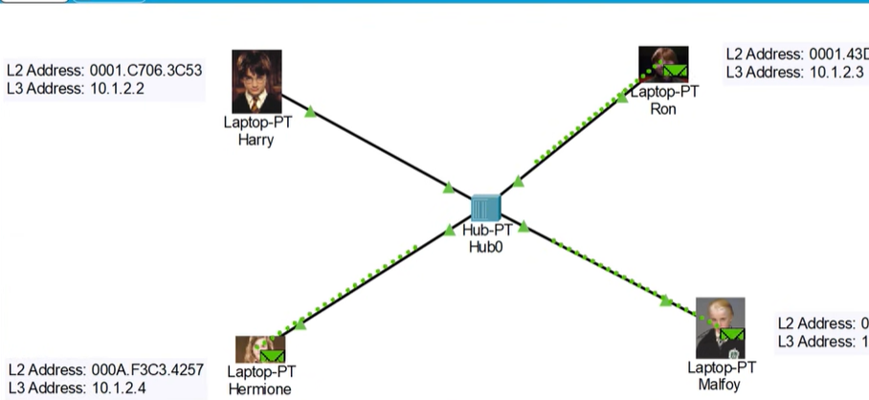

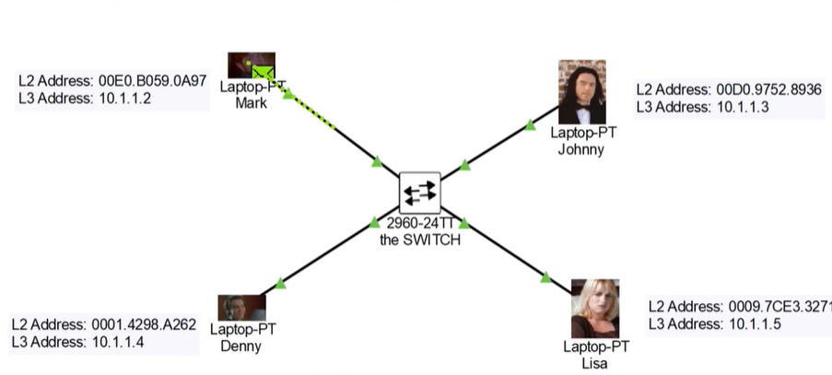

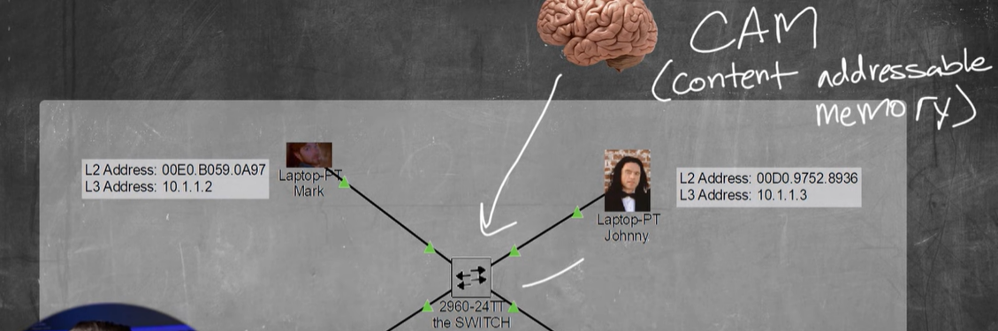

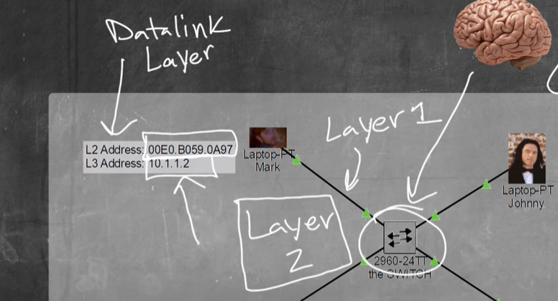

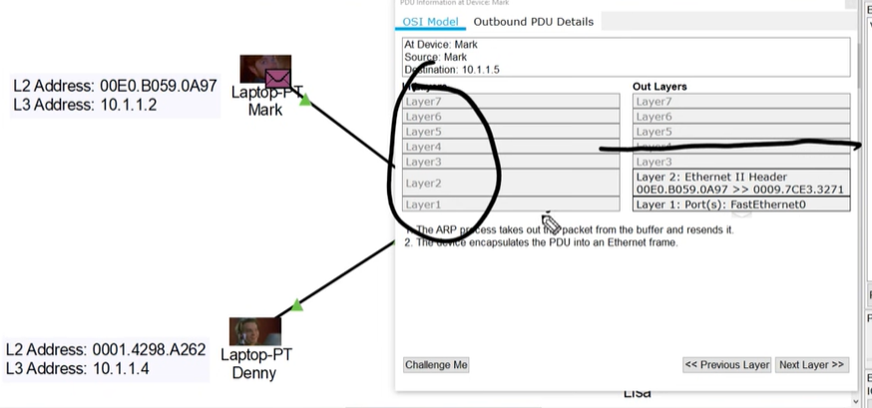

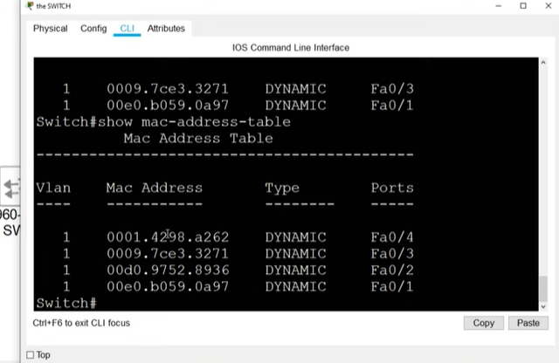

Layer2 – switch and frames that’s it.

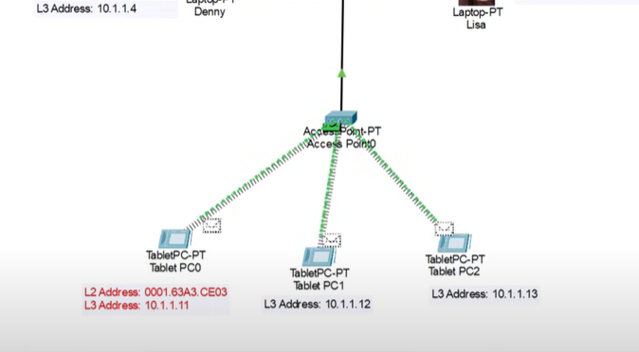

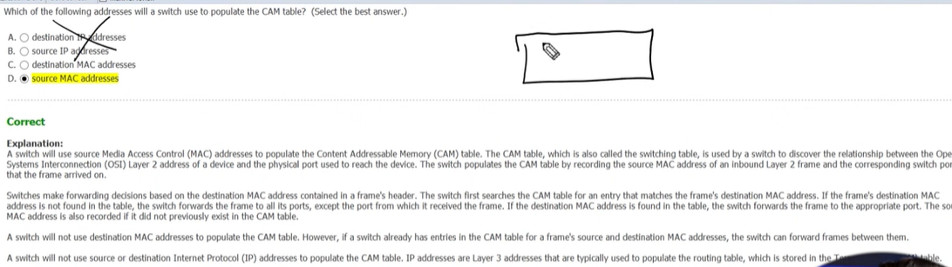

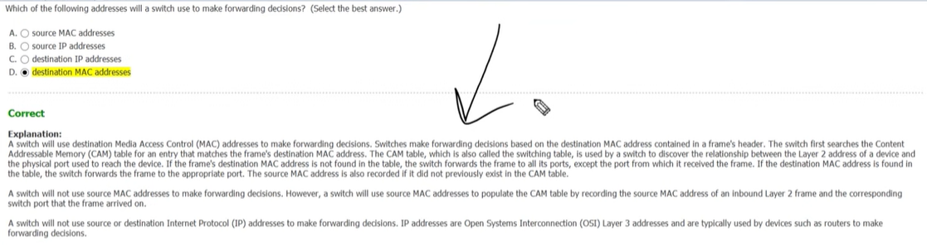

***What is a ROUTER?***

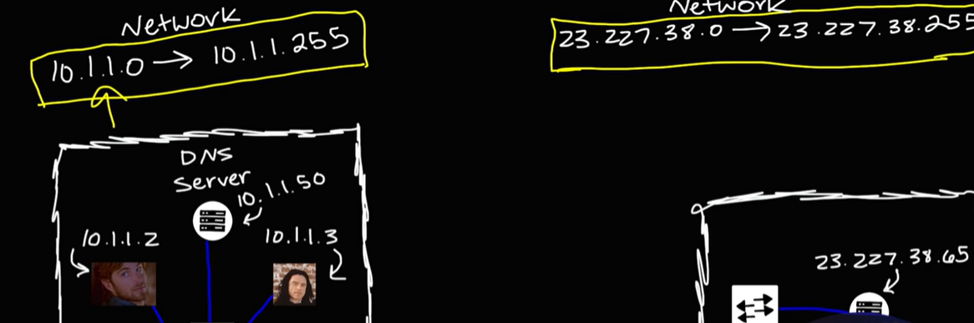

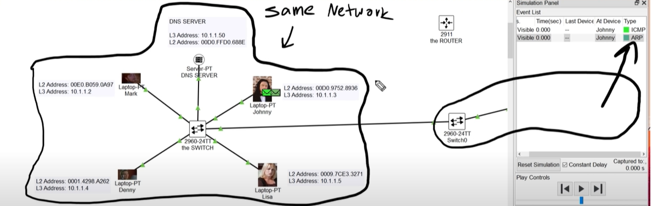

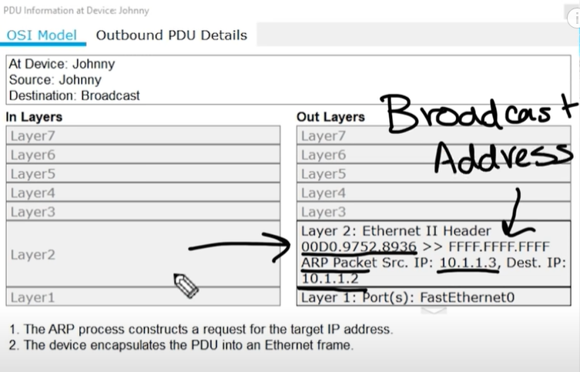

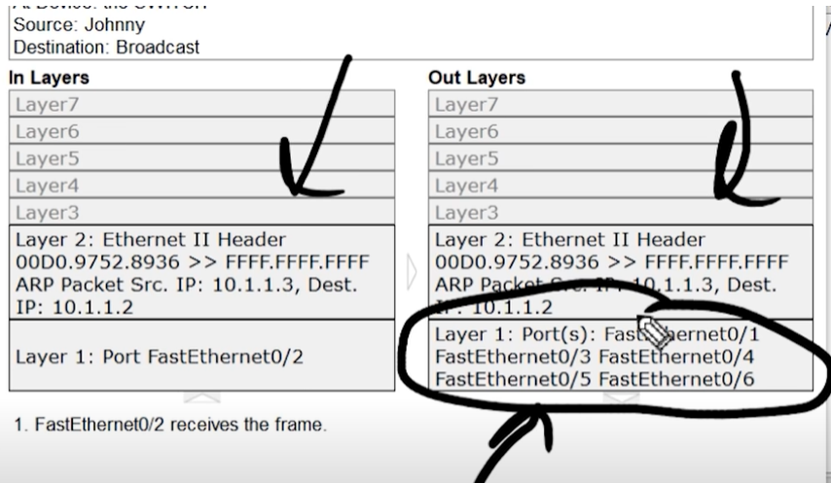

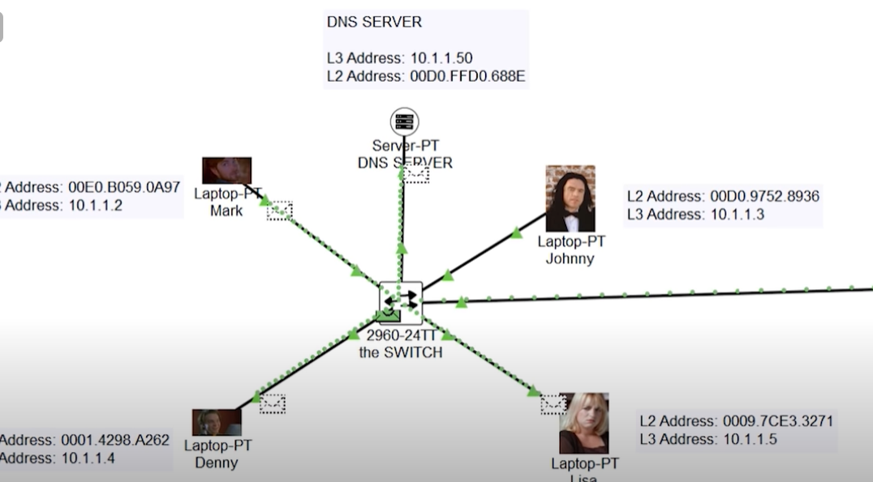

ping an ip address outside of the local network----

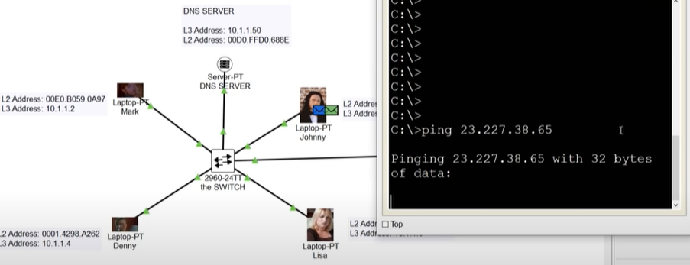

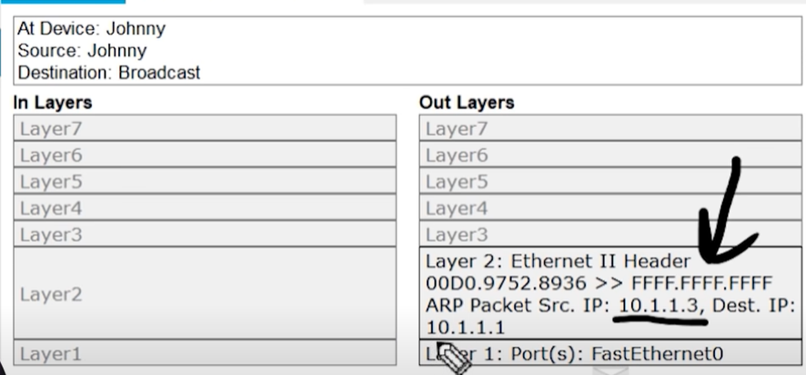

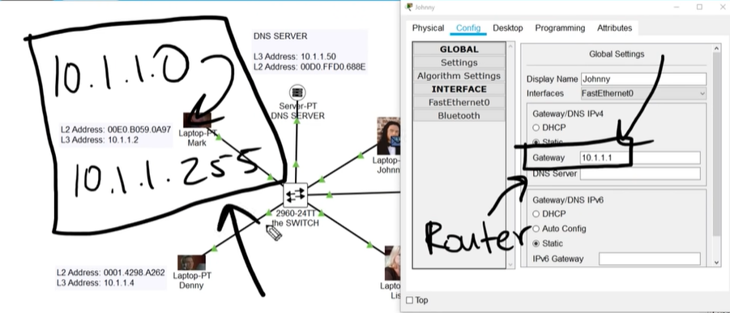

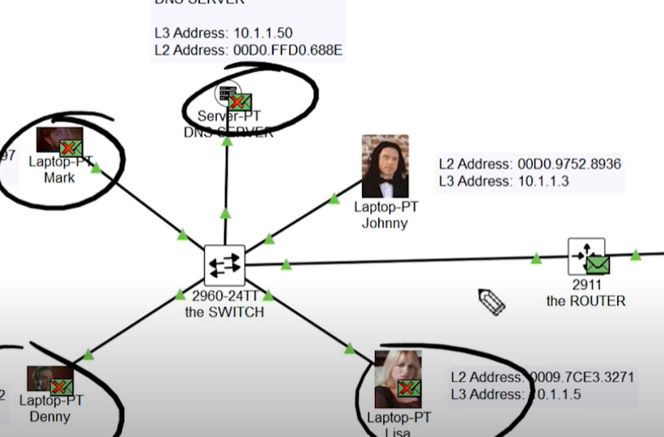

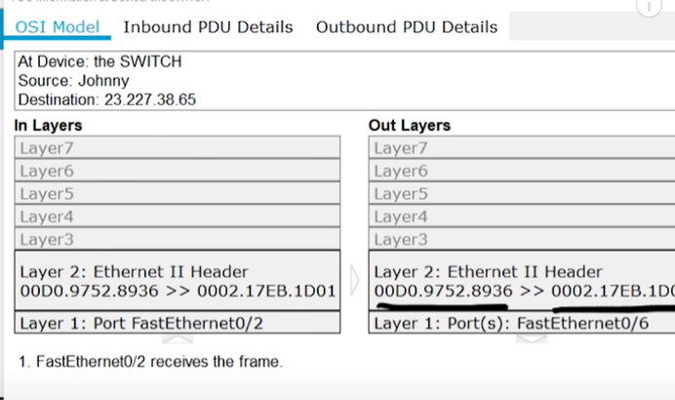

routers are layer3 devices, they understand ip addresses

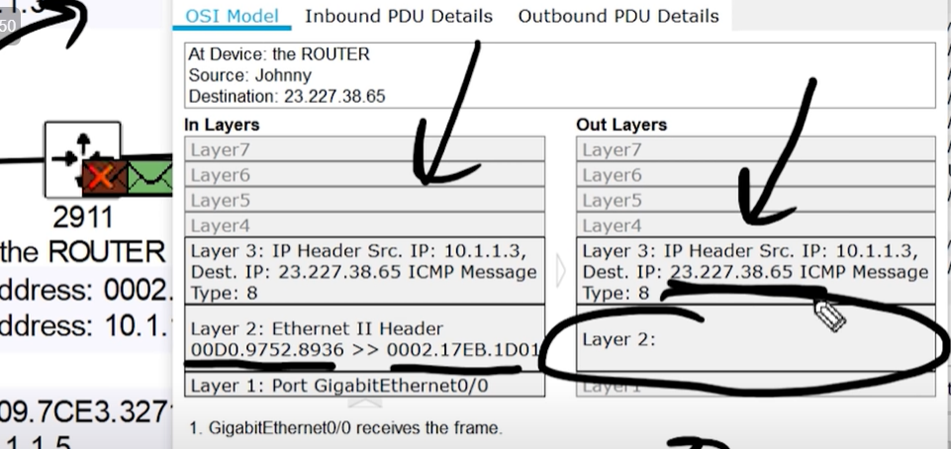

the layer2 on the out layers is blank because, the router does not know the destination mac address of ip 23.227.38.65, so it sends a broadcast message, to find out the mac address

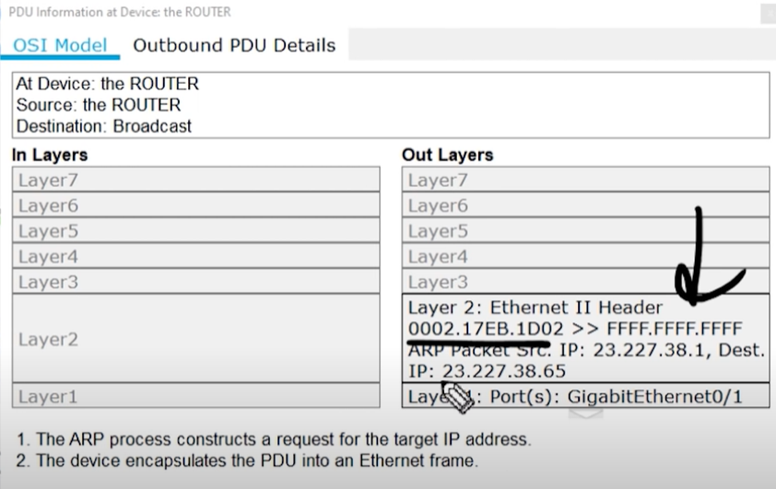

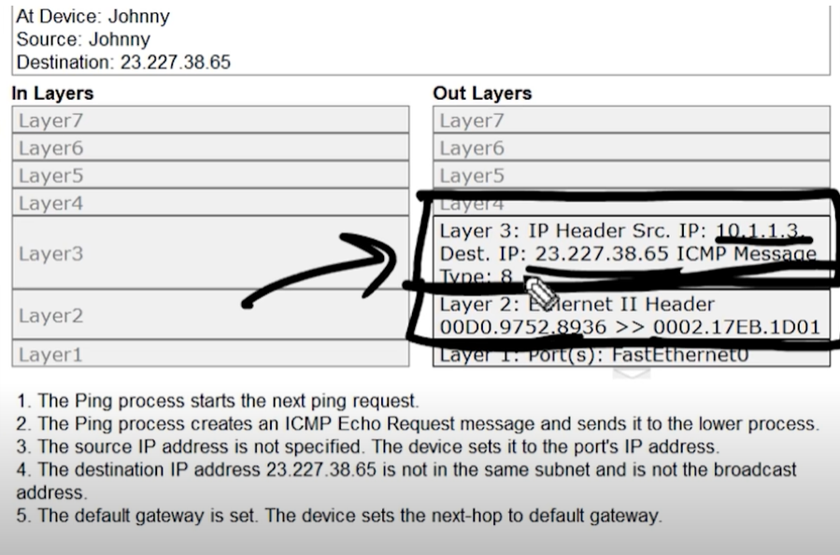

Memory of a router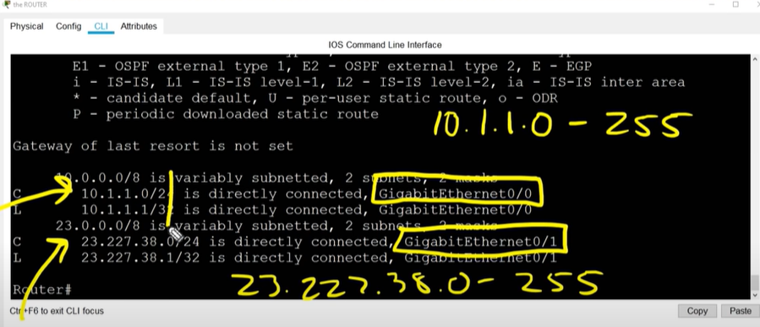

What is TCP/IP and OSI models?

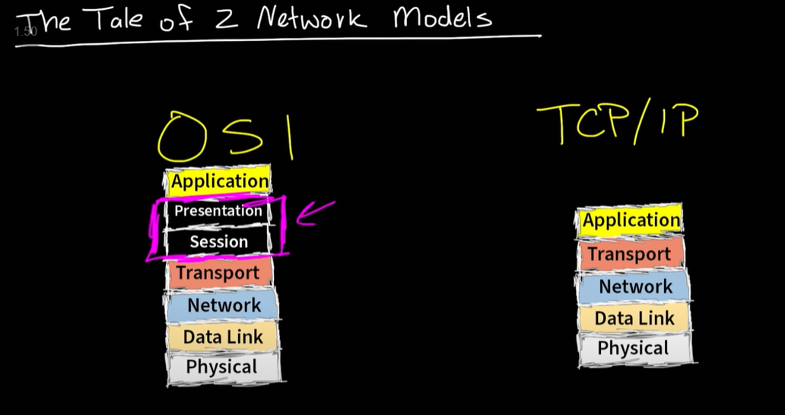

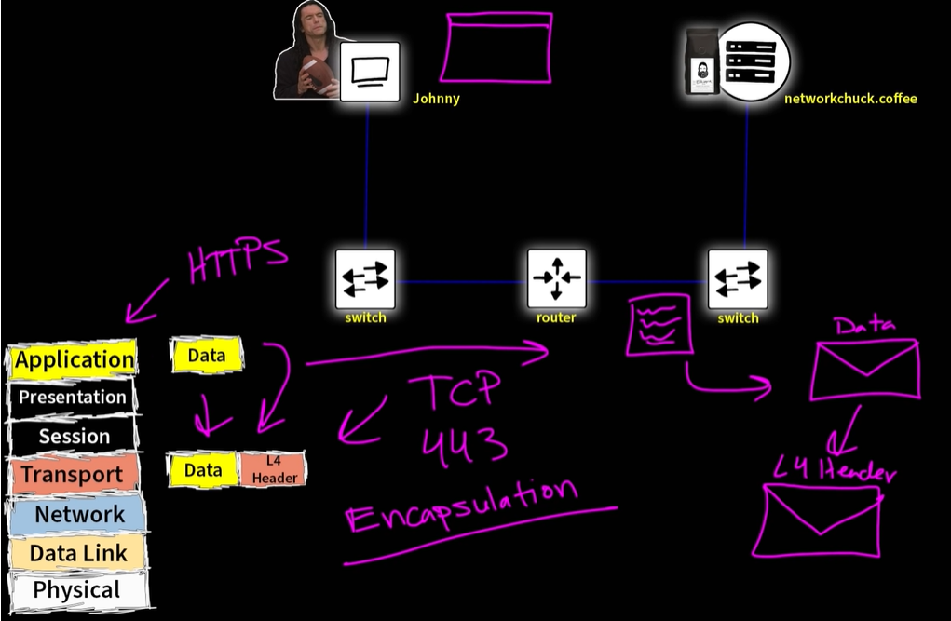

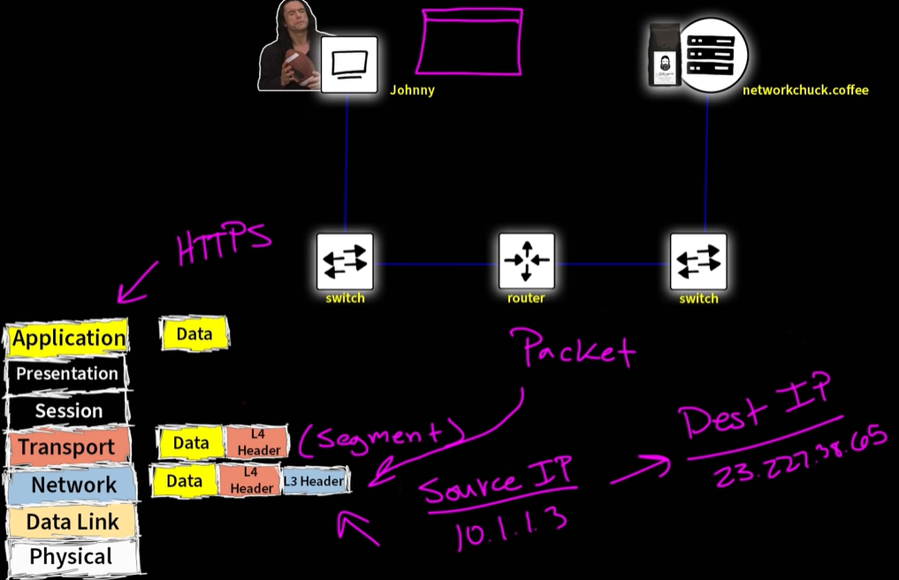

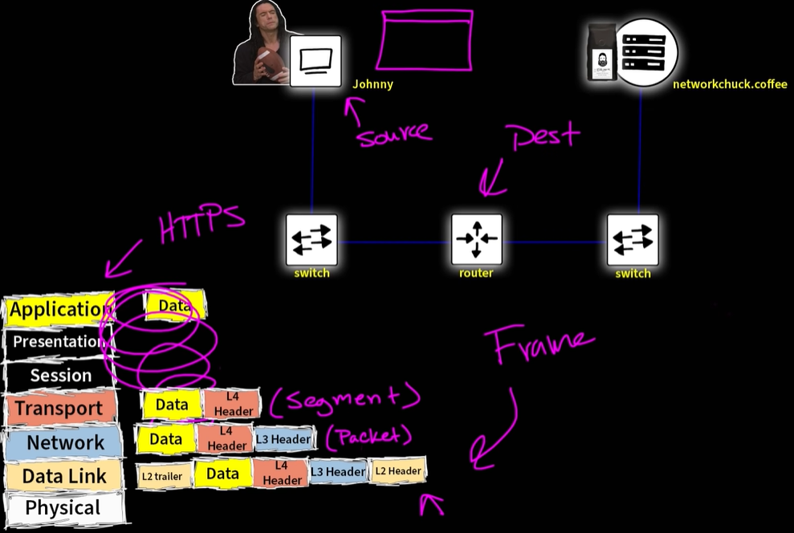

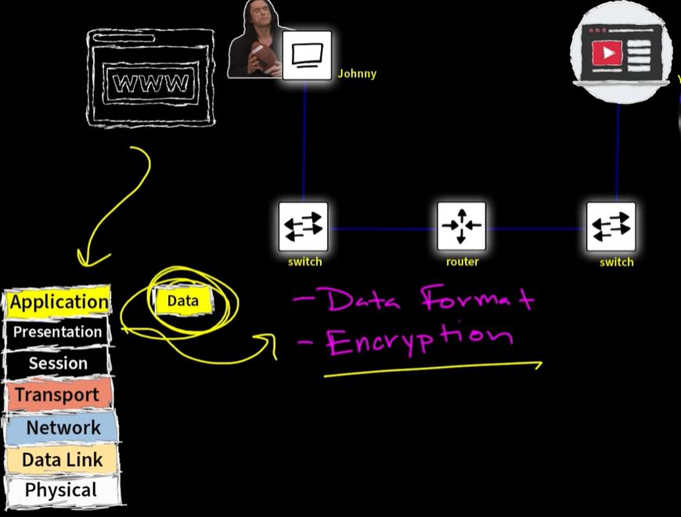

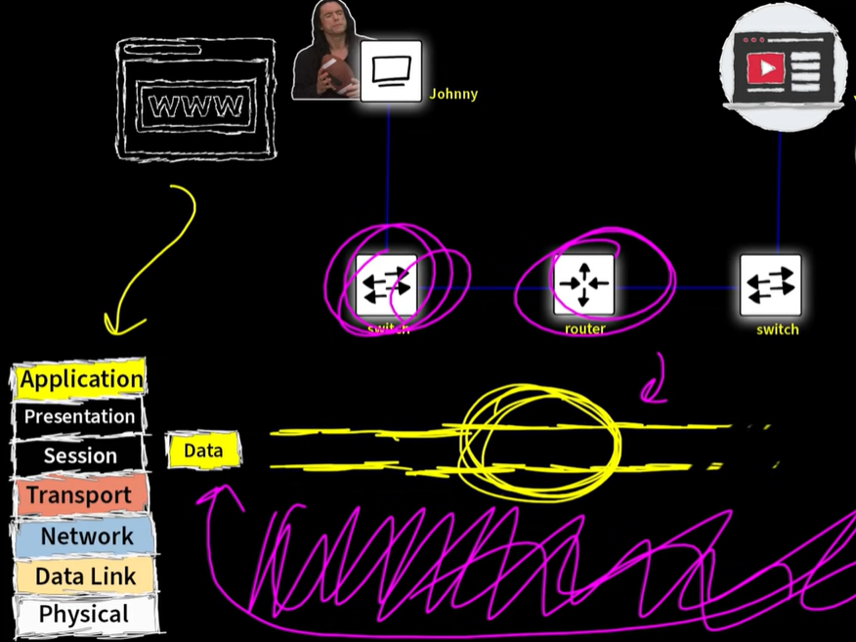

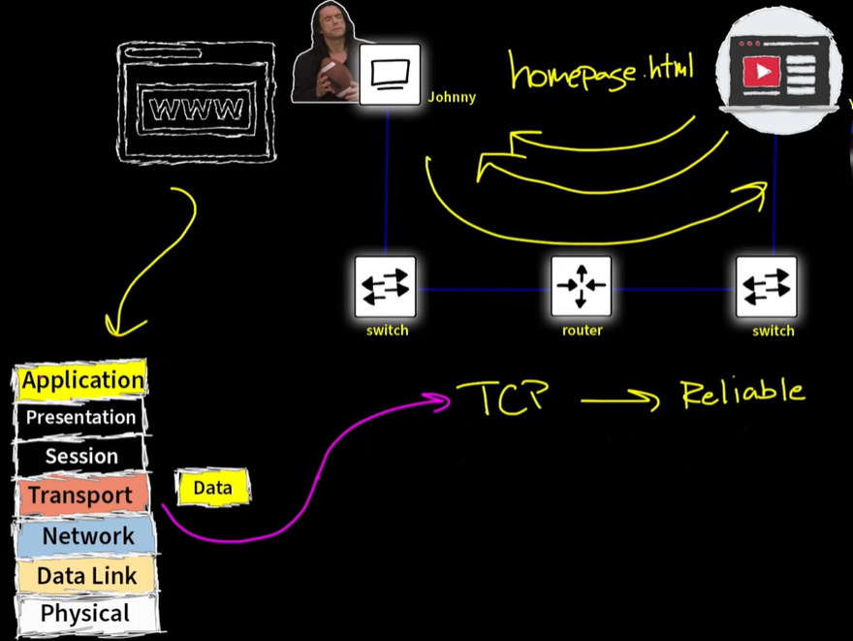

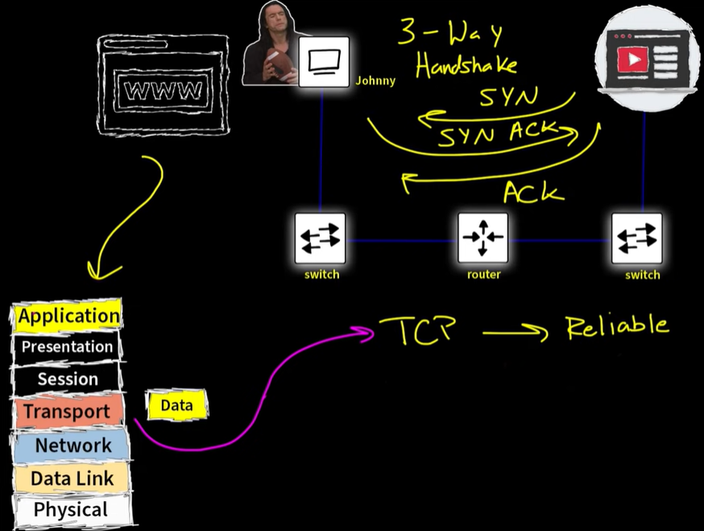

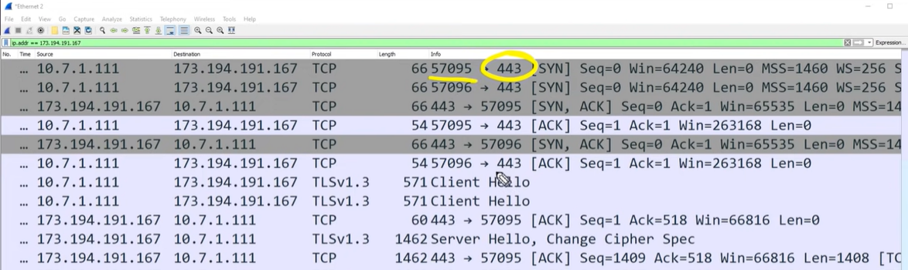

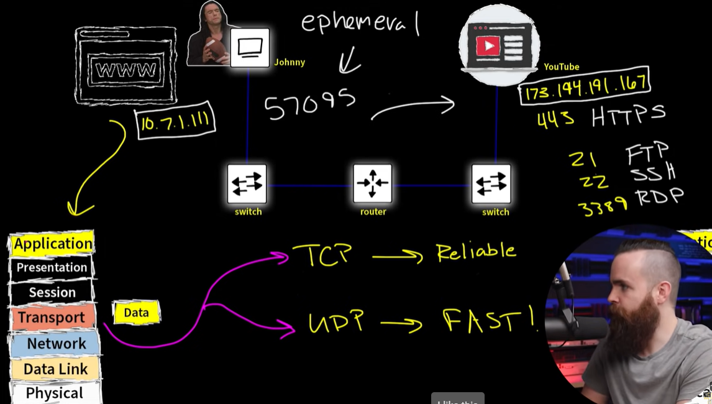

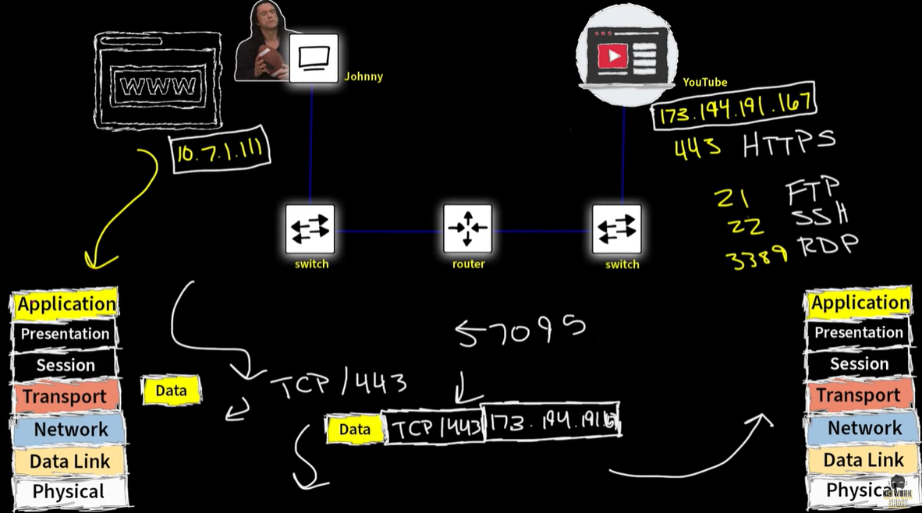

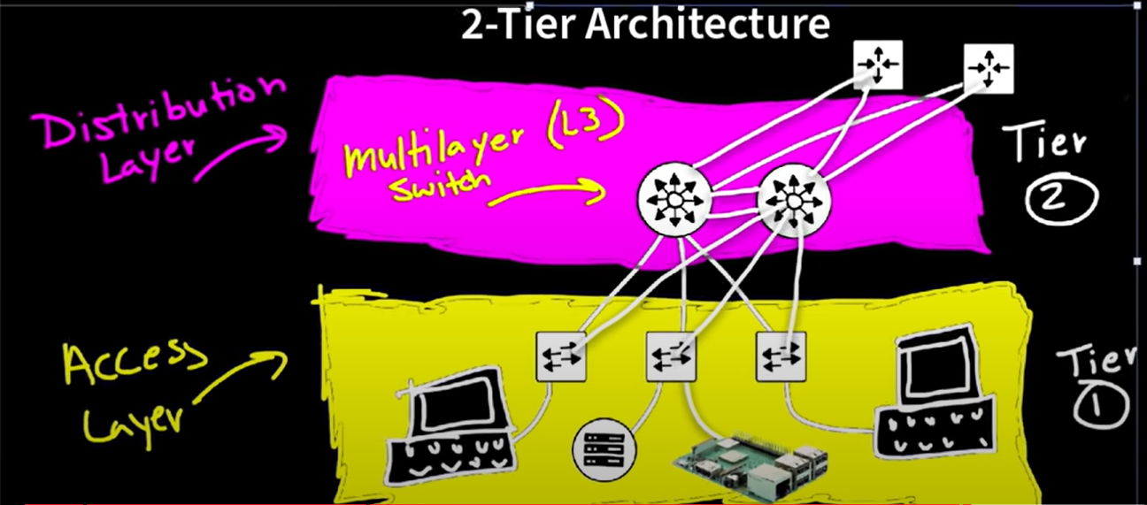

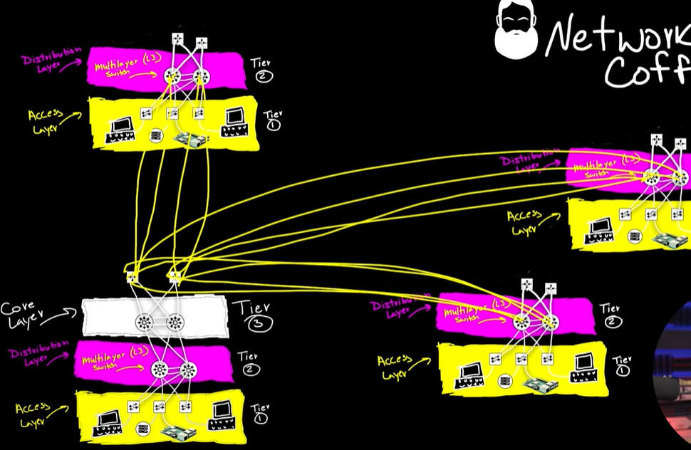

Data center network design to accomplish 2-hop east/west traffic.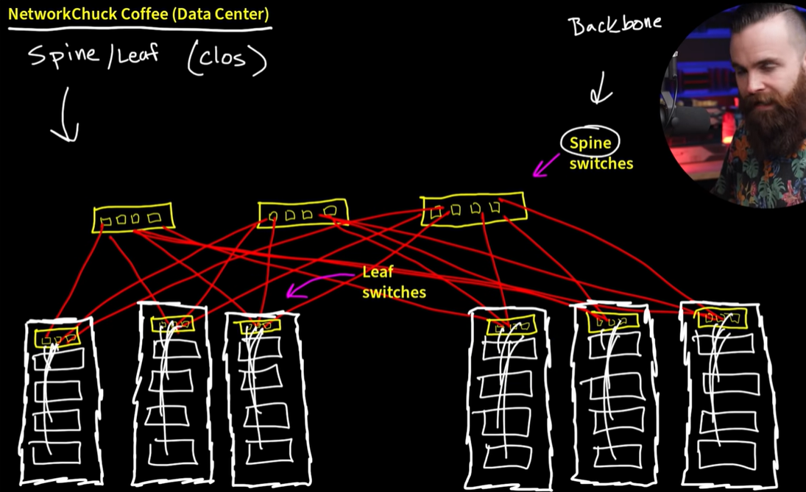

WAN (Wide area network)

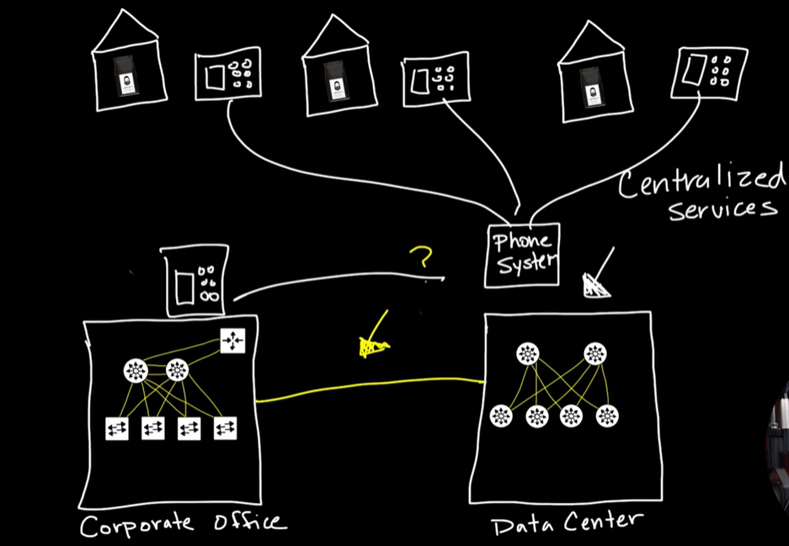

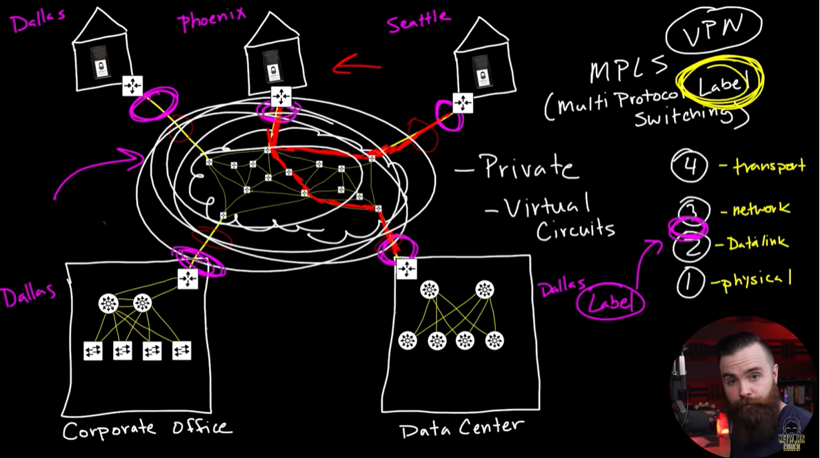

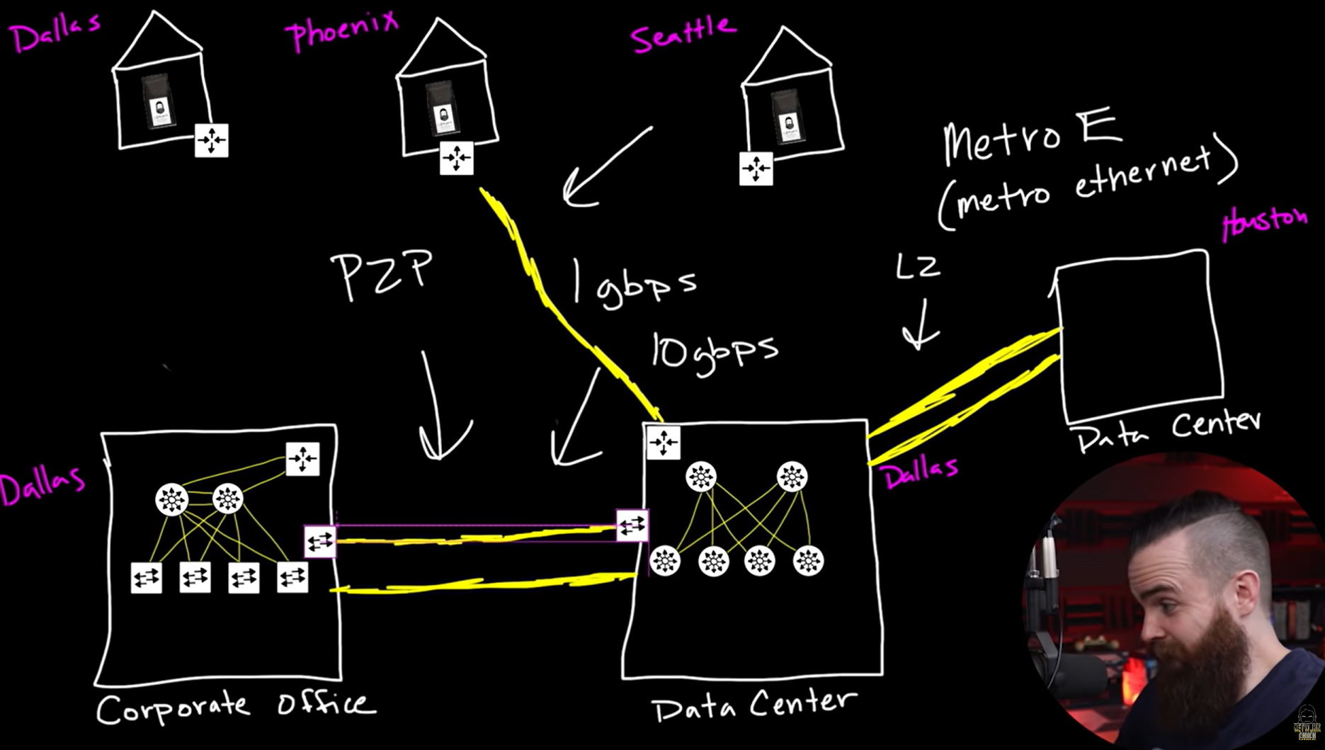

IP ADDRESSES

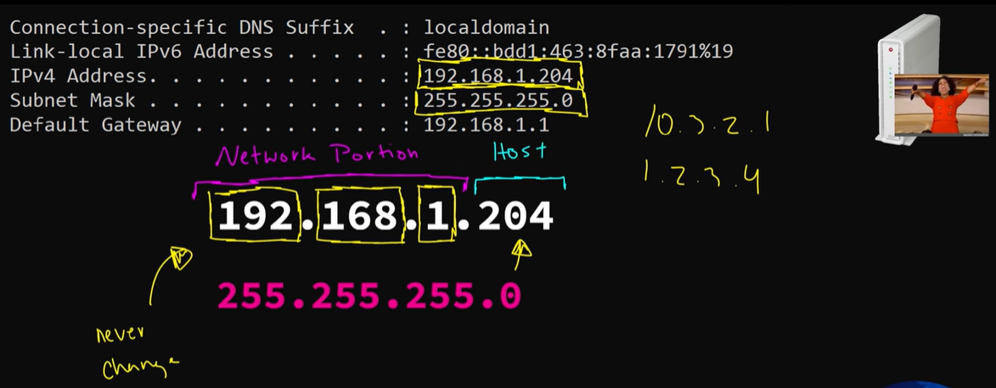

TOTAL OF 253 USABLE IP ADDRESSES

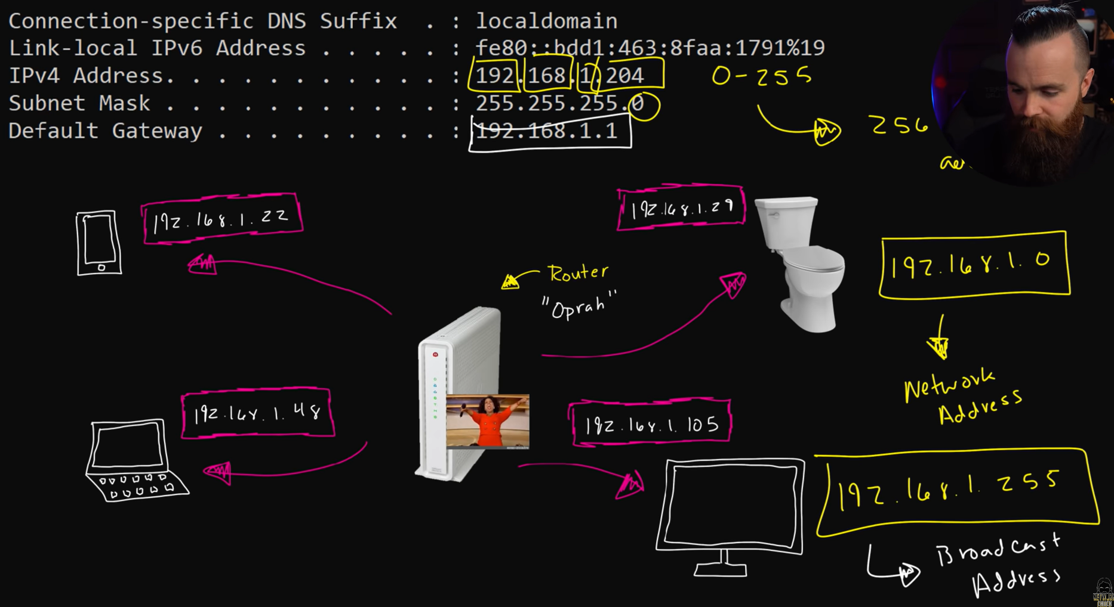

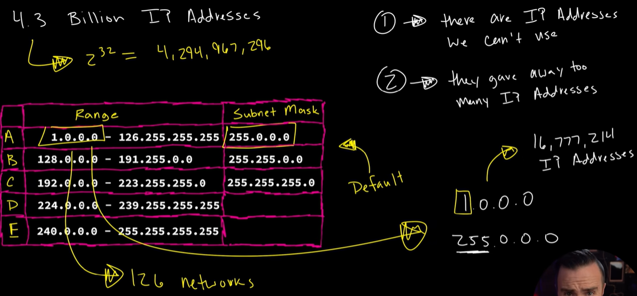

while class A has only 126 networks with each containing 16 mil hosts. What it here taking a class, a network, and we cut it up and made it smaller with a different subnet mask. Other than its default, we call that a classless network

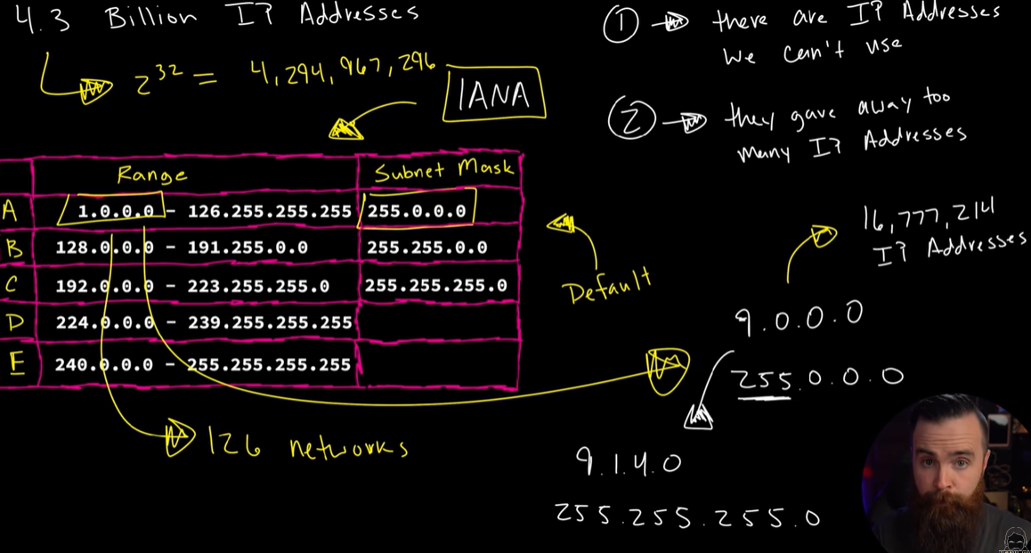

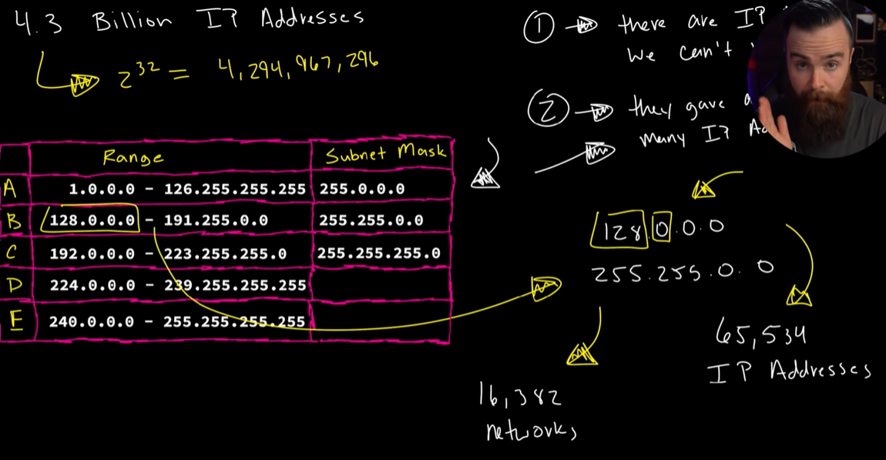

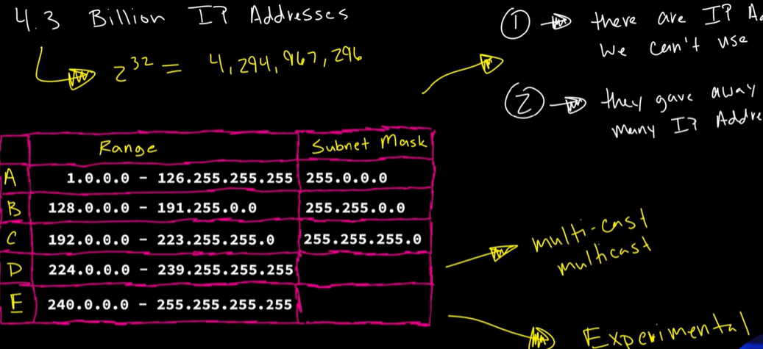

our devices have 16 mil virtual ip addresses ready to respond to itself!!!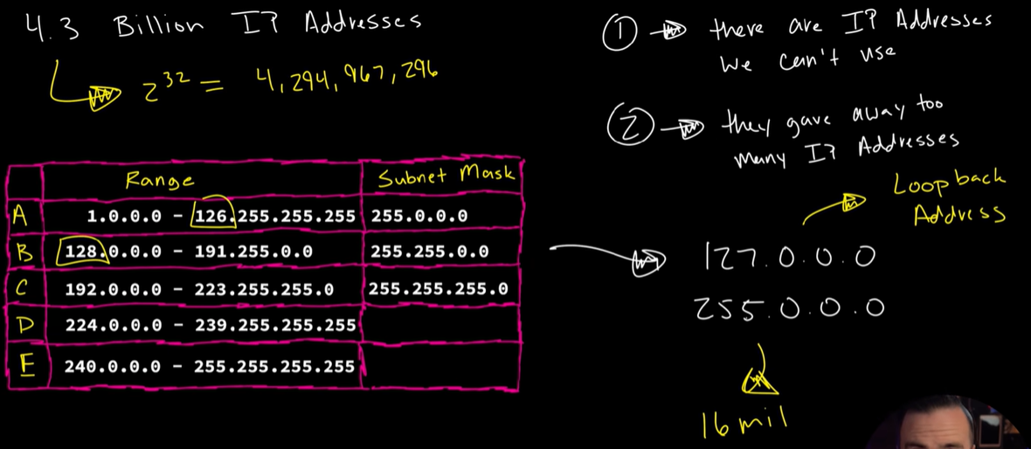

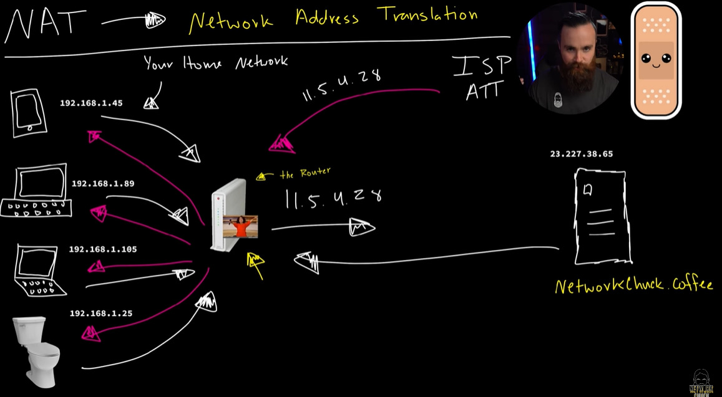

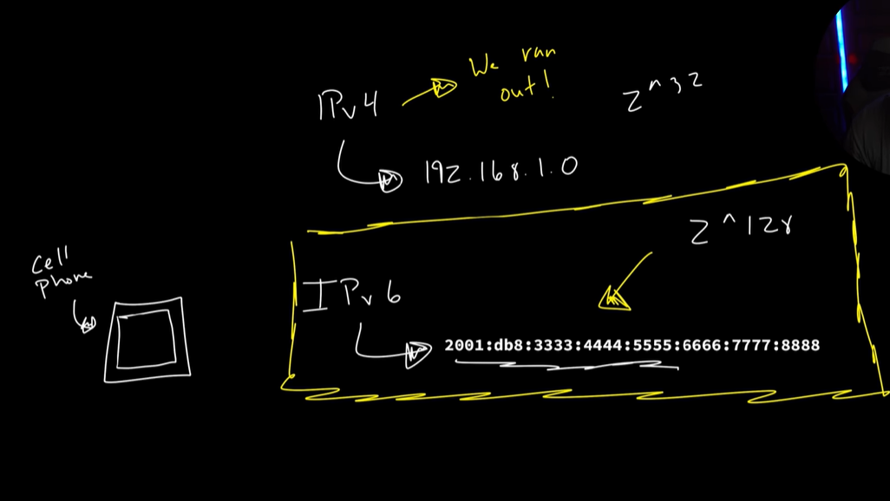

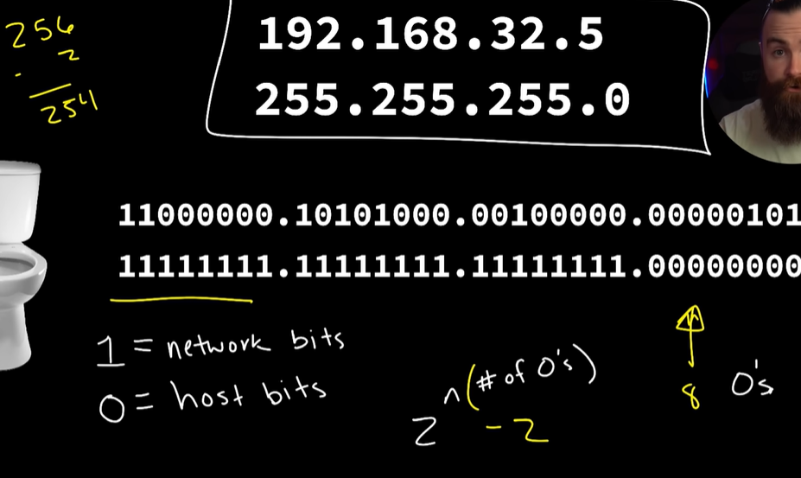

If you need more ip addresses in a network, collapse a network(seal the network bits), i.e change the subnet mask, in this example 2 power 9 – 2 = 508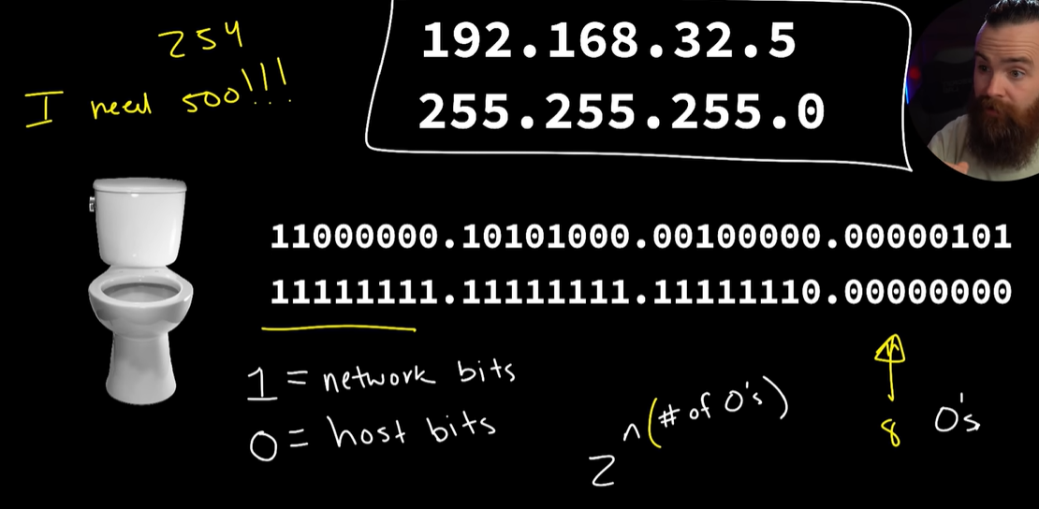

if you need more networks steal the host bits, in this example to create 4 networks, we need to steal 2 host bits, therefore changing the subnet mask to 255.255.255.192

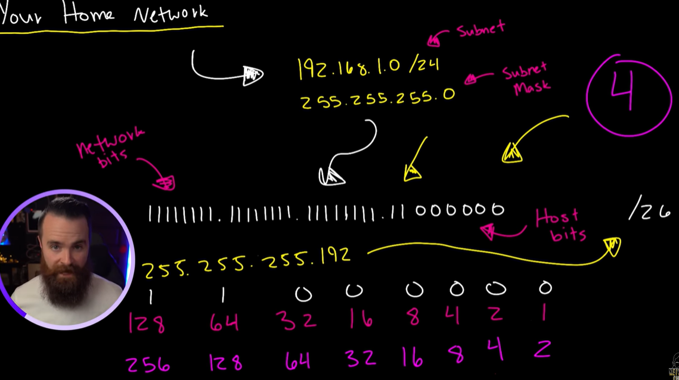

to find the increment find the last network bit we have, in this example the last network bit points to 64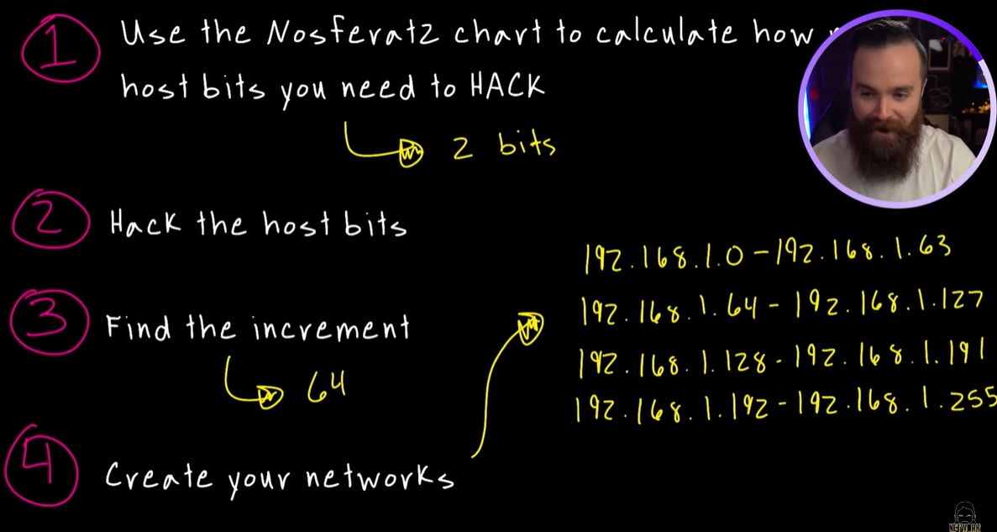

**TCP Fundamentals:**

1. *Steps of a 3-Way Handshake for Establishing the Connection :*

The three steps involved in establishing a connection using the 3-way handshake process in TCP are as follows:

* The client sends the SYN (synchronize) message to the server: When a client requests to connect to a server, it sends the message to the server with the SYN flag set to 1. The message also includes: The sequence number (any random 32-bit number). The ACK (which is set to 0 in this case). The window size. The maximum segment size. For example, if the window size is 3000 bits and the maximum segment size is 300 bits, the connection can send a maximum of 10 data segments (3000/300 = 10).
* The server responds with the SYN and the ACK (synchronize-acknowledge) message to the client: After receiving the synchronization request, the server sends the client an acknowledgment by changing the ACK flag to '1'. The ACK's acknowledgment number is one higher than the sequence number received. If the client sends an SYN with a sequence number of 2000, the server will send the ACK using acknowledgment number = 20001. If the server wants to create the connection, it sets the SYN flag to '1' and transmits it to the client. The SYN sequence number used here will be different from the SYN used by the client. The server also informs the client of its window size and maximum segment size. After this step is completed, the connection is established from the client to the server.
* The client sends the ACK (acknowledge) message to the server: The client will set the ACK flag to '1' after receiving the SYN from the server and transmits it with an acknowledgment number 1 greater than the server's SYN sequence number. The SYN flag has been set to '0' in this case. The connection between the server and the client is now formed after this phase is completed.

1. *Maximum Transmission unit vs TCP Max Segment Size*

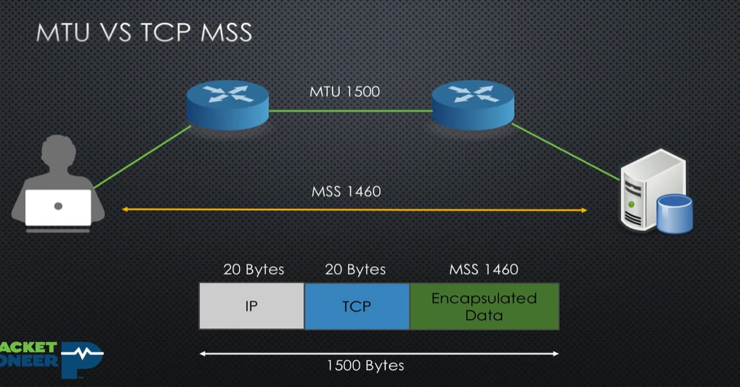

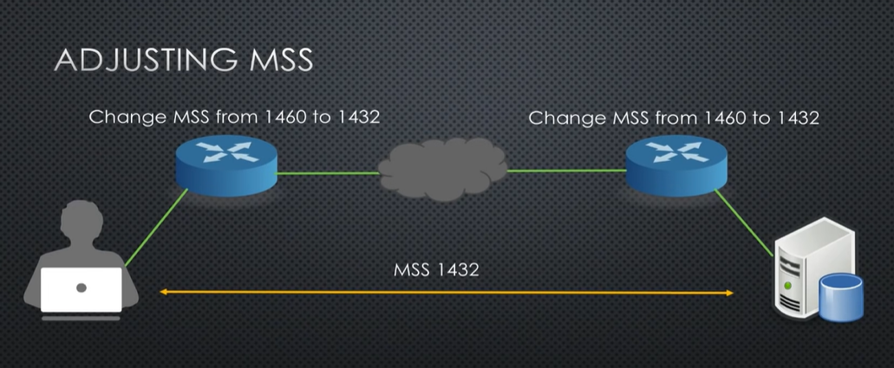

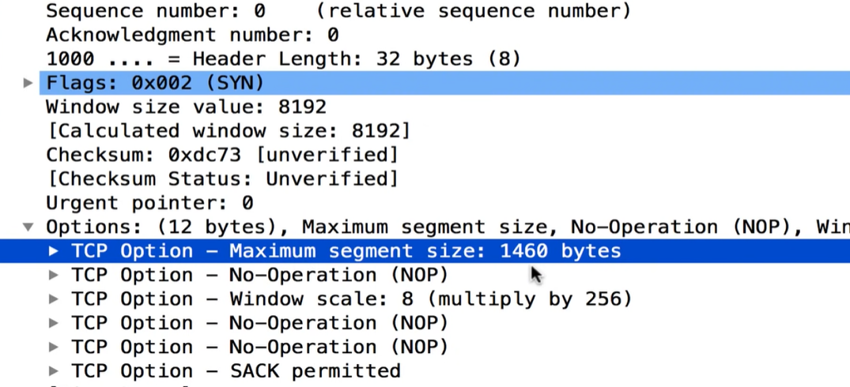

1. *Retransmission And Window size*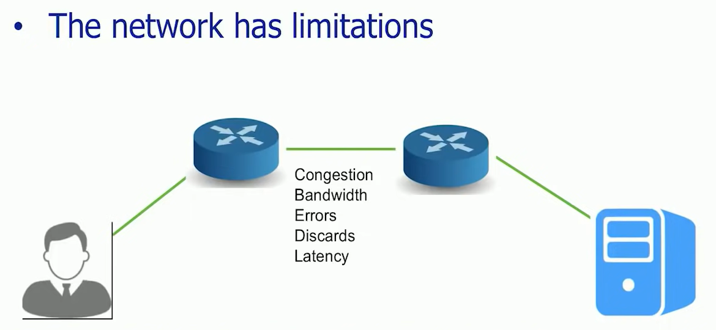

Tcp slow start

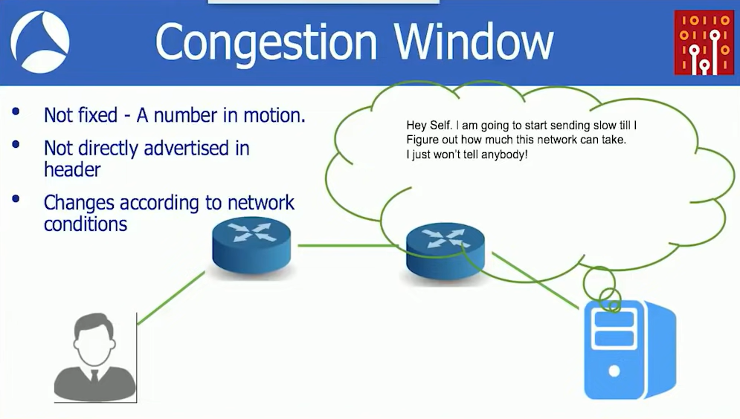

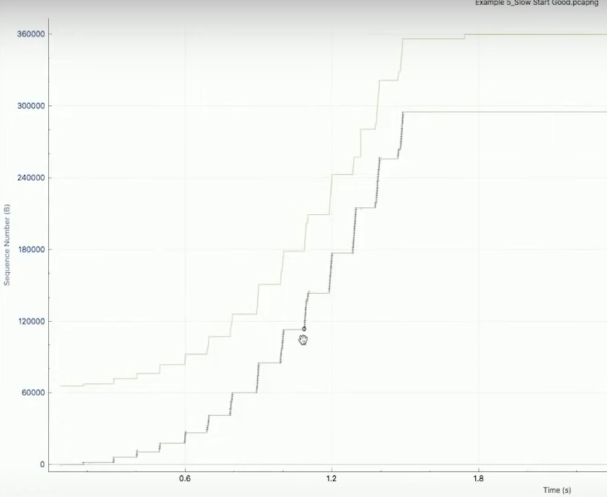

1. *Windows scaling:*

For more efficient use of high-bandwidth networks, a larger TCP window size may be used. The TCP window size field controls the flow of data and is limited to 2 bytes, or a window size of 65,535 bytes. Since the size field can't be expanded, a scaling factor is used. TCP window scale is an option used to increase the maximum window size from 65,535 bytes to 1 Gigabyte. The window scale option is used only during the TCP three-way handshake. The window scale value represents the number of bits to left-shift the 16-bit window size field. The window scale value can be set from 0 (no shift) to 14. To calculate the true window size, multiply the window size by 2^S where S is the scale value. For Example: If the window size is 65,535 bytes with a window scale factor of 3. True window size = 65535*2^3 True window size = 524280

1. *TCP Keep-Alive* --

is an instruction that allows a single TCP connection to remain open for multiple requests/responses. By default, connections close after each request. When someone visits your site, their browser needs to create new connections to request each of the files that make up your web pages (e.g. images, Javascript, and CSS stylesheets), a process that can lead to high page load times. Connection requests with Keep Alive Off vs. Keep Alive On

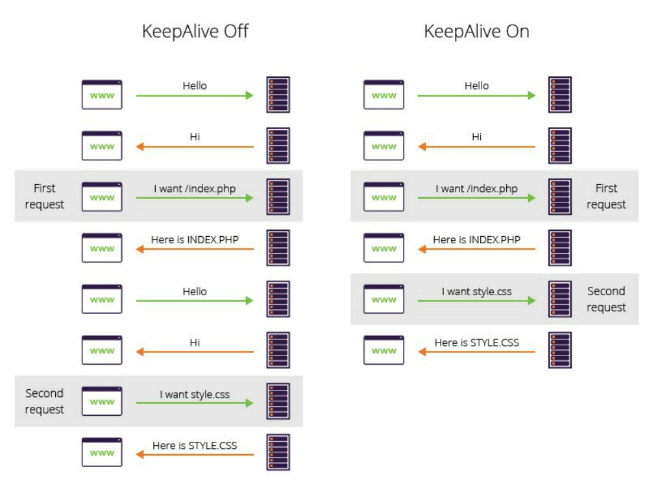

Enabling the keep-alive header allows you to serve all web page resources over a single connection. Keep-alive also reduces both CPU and memory usage on your server.

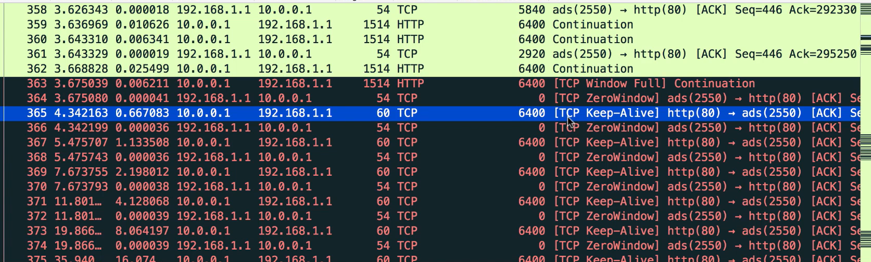

1. *Fin vs Reset*:

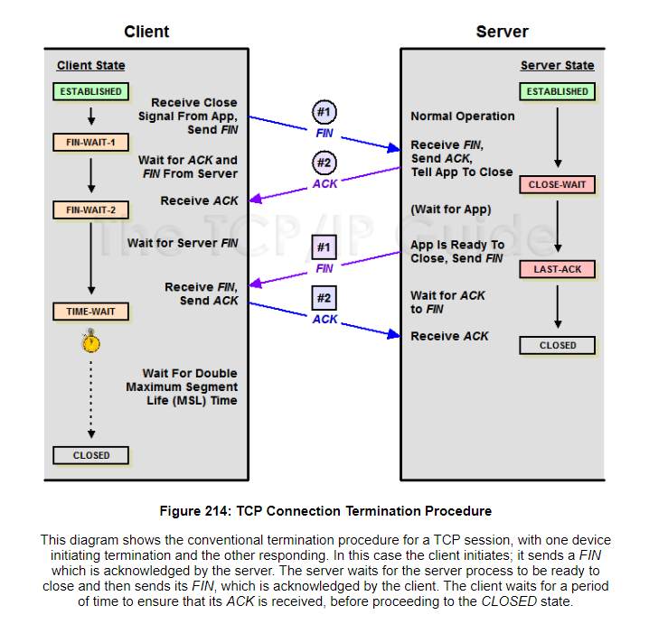

The TCP RST flag indicates that connection should be immediately terminated, and this happens mostly because of a fatal error. If in case, the connection has already been closed or idle from one side (side A) and the other side (side B) suddenly comes back and wishes to continue the session for data transfer, host (side A) usually responds by sending a RST packet back to the same connection and stating that no longer interested in data transfer. RST bit will be set to high in the TCP header flag.

1. The packet is an initial SYN packet trying to establish a connection to a server port on which no process is listening.
2. The packet arrives on a TCP connection that was previously established but the local application has already closed its socket or exited and the OS has closed the socket.

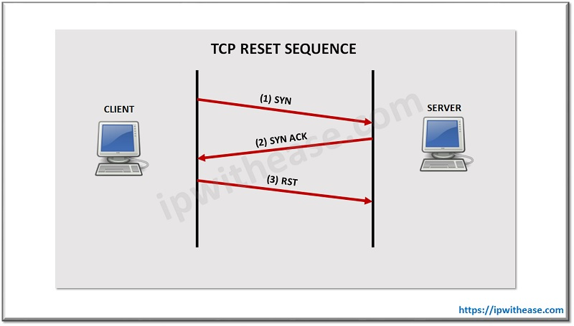

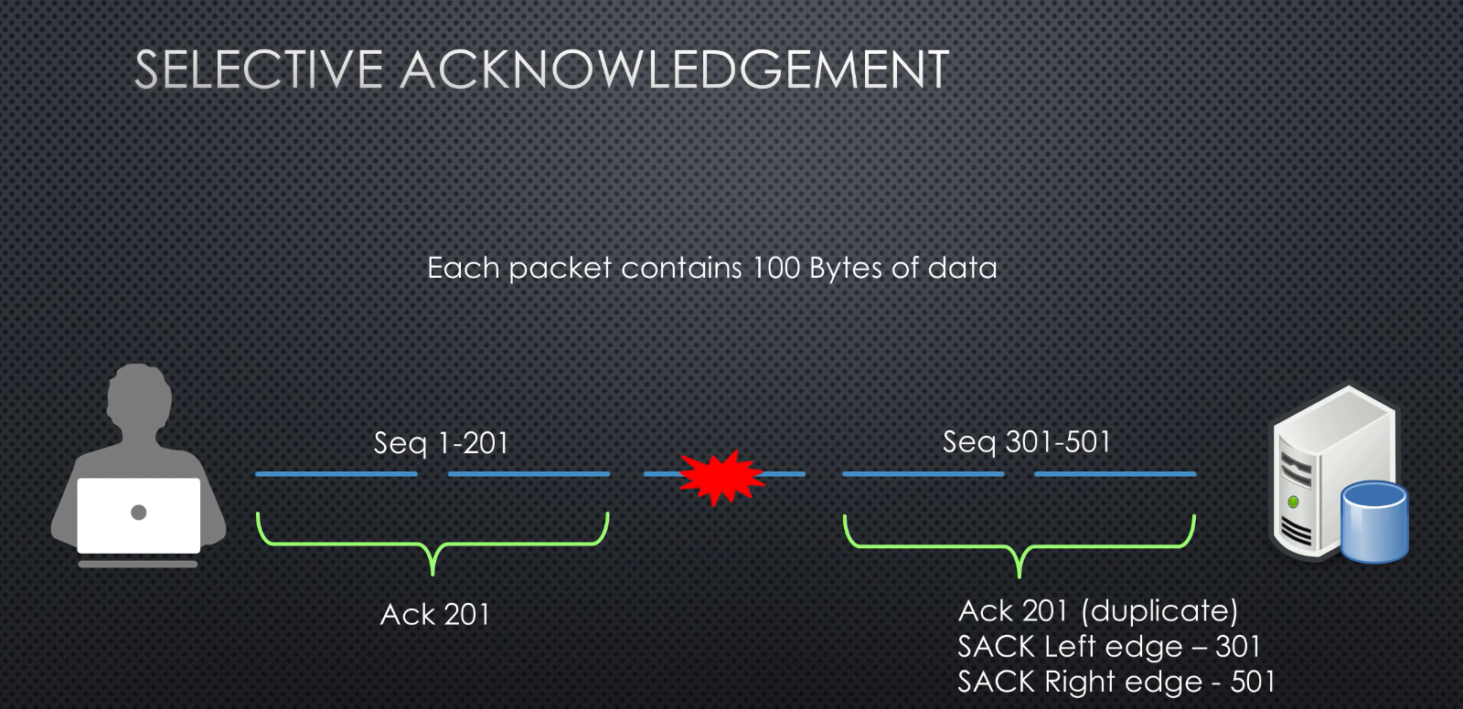

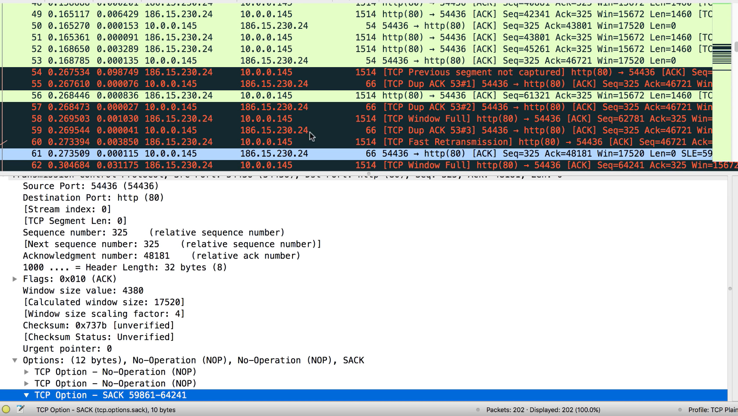

**Ethernet frame**

Basic frame format which is required for all MAC implementation is defined in IEEE 802.3 standard. Though several optional formats are being used to extend the protocol’s basic capability. Ethernet frame starts with Preamble and SFD, both work at the physical layer. Ethernet header contains both the Source and Destination MAC address, after which the payload of the frame is present. The last field is CRC which is used to detect the error. Now, let’s study each field of basic frame format.

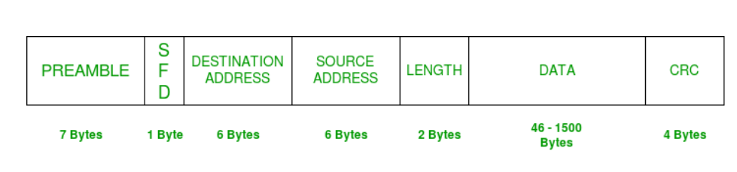

* PREAMBLE – Ethernet frame starts with a 7-Bytes Preamble. This is a pattern of alternative 0’s and 1’s which indicates starting of the frame and allow sender and receiver to establish bit synchronization. Initially, PRE (Preamble) was introduced to allow for the loss of a few bits due to signal delays. But today’s high-speed Ethernet doesn’t need Preamble to protect the frame bits. PRE (Preamble) indicates the receiver that frame is coming and allow the receiver to lock onto the data stream before the actual frame begins.
* Start of frame delimiter (SFD) – This is a 1-Byte field that is always set to 10101011. SFD indicates that upcoming bits are starting the frame, which is the destination address. Sometimes SFD is considered part of PRE, this is the reason Preamble is described as 8 Bytes in many places. The SFD warns station or stations that this is the last chance for synchronization.
* Destination Address – This is a 6-Byte field that contains the MAC address of the machine for which data is destined.
* Source Address – This is a 6-Byte field that contains the MAC address of the source machine. As Source Address is always an individual address (Unicast), the least significant bit of the first byte is always 0.
* Length – Length is a 2-Byte field, which indicates the length of the entire Ethernet frame. This 16-bit field can hold a length value between 0 to 65534, but length cannot be larger than 1500 Bytes because of some own limitations of Ethernet.
* Data – This is the place where actual data is inserted, also known as Payload. Both IP header and data will be inserted here if Internet Protocol is used over Ethernet. The maximum data present may be as long as 1500 Bytes. In case data length is less than minimum length i.e. 46 bytes, then padding 0’s is added to meet the minimum possible length.
* Cyclic Redundancy Check (CRC) – CRC is 4 Byte field. This field contains a 32-bits hash code of data, which is generated over the Destination Address, Source Address, Length, and Data field. If the checksum computed by destination is not the same as sent checksum value, data received is corrupted.

CRC or Cyclic Redundancy Check is a method of detecting accidental changes/errors in the communication channel.   
CRC uses **Generator Polynomial**which is available on both sender and receiver side. An example generator polynomial is of the form like x3 + x + 1. This generator polynomial represents key 1011. Another example is x2 + 1 that represents key 101.

n : Number of bits in data to be sent

from sender side.

k : Number of bits in the key obtained

from generator polynomial.

**Sender Side (Generation of Encoded Data from Data and Generator Polynomial (or Key)):**

1. The binary data is first augmented by adding k-1 zeros in the end of the data
2. Use ***modulo-2 binary division*** to divide binary data by the key and store remainder of division.
3. Append the remainder at the end of the data to form the encoded data and send the same

**Receiver Side (Check if there are errors introduced in transmission)**  
Perform modulo-2 division again and if the remainder is 0, then there are no errors.

In this article we will focus only on finding the remainder i.e. check word and the code word.

**Modulo 2 Division:**  
The process of modulo-2 binary division is the same as the familiar division process we use for decimal numbers. Just that instead of subtraction, we use XOR here.

* In each step, a copy of the divisor (or data) is XORed with the k bits of the dividend (or key).
* The result of the XOR operation (remainder) is (n-1) bits, which is used for the next step after 1 extra bit is pulled down to make it n bits long.
* When there are no bits left to pull down, we have a result. The (n-1)-bit remainder which is appended at the sender side.

**Illustration:**  
**Example 1 (No error in transmission):**

Data word to be sent - 100100

Key - 1101 [ Or generator polynomial x3 + x2 + 1]

Sender Side:

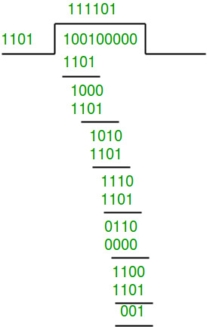

Therefore, the remainder is 001 and hence the encoded

data sent is 100100001.

Receiver Side:

Code word received at the receiver side 100100001

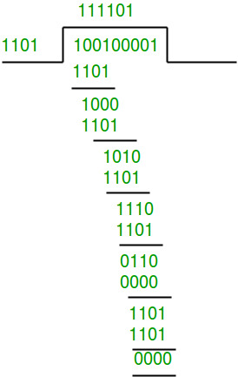

Therefore, the remainder is all zeros. Hence, the

data received has no error.

**Example 2: (Error in transmission)**

Data word to be sent - 100100

Key - 1101

Sender Side:



Therefore, the remainder is 001 and hence the

code word sent is 100100001.

Receiver Side

Let there be an error in transmission media

Code word received at the receiver side - 100000001

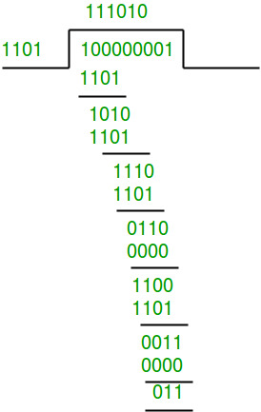

Since the remainder is not all zeroes, the error  
is detected at the receiver side.

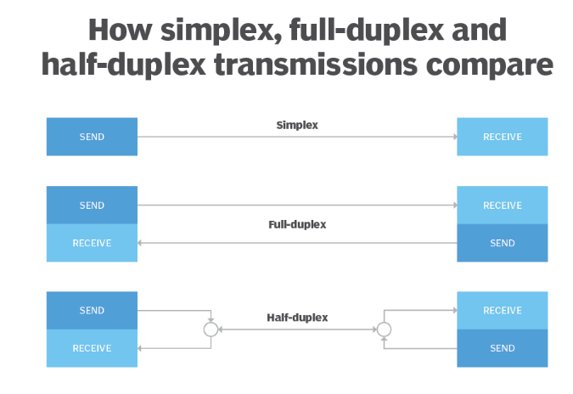

**SSL/TLS**

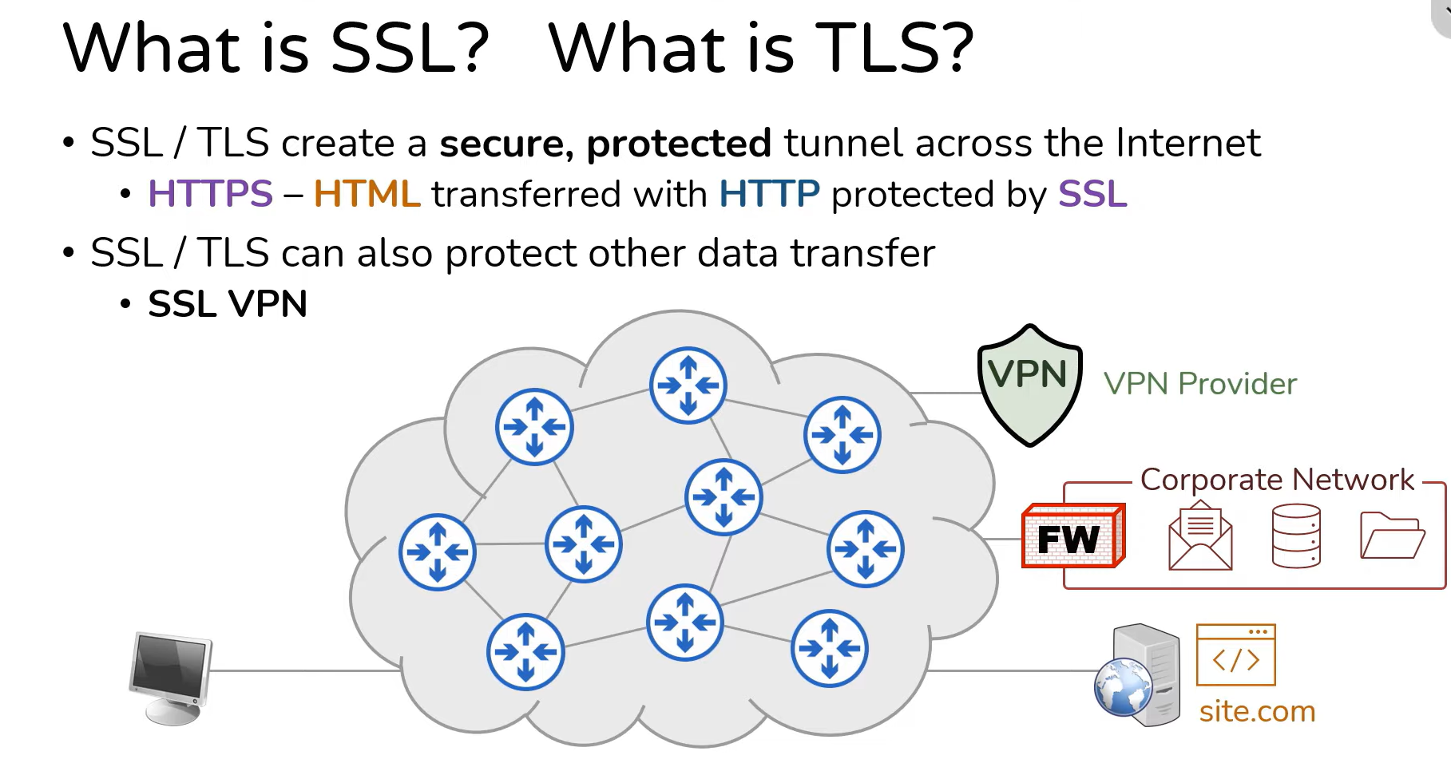

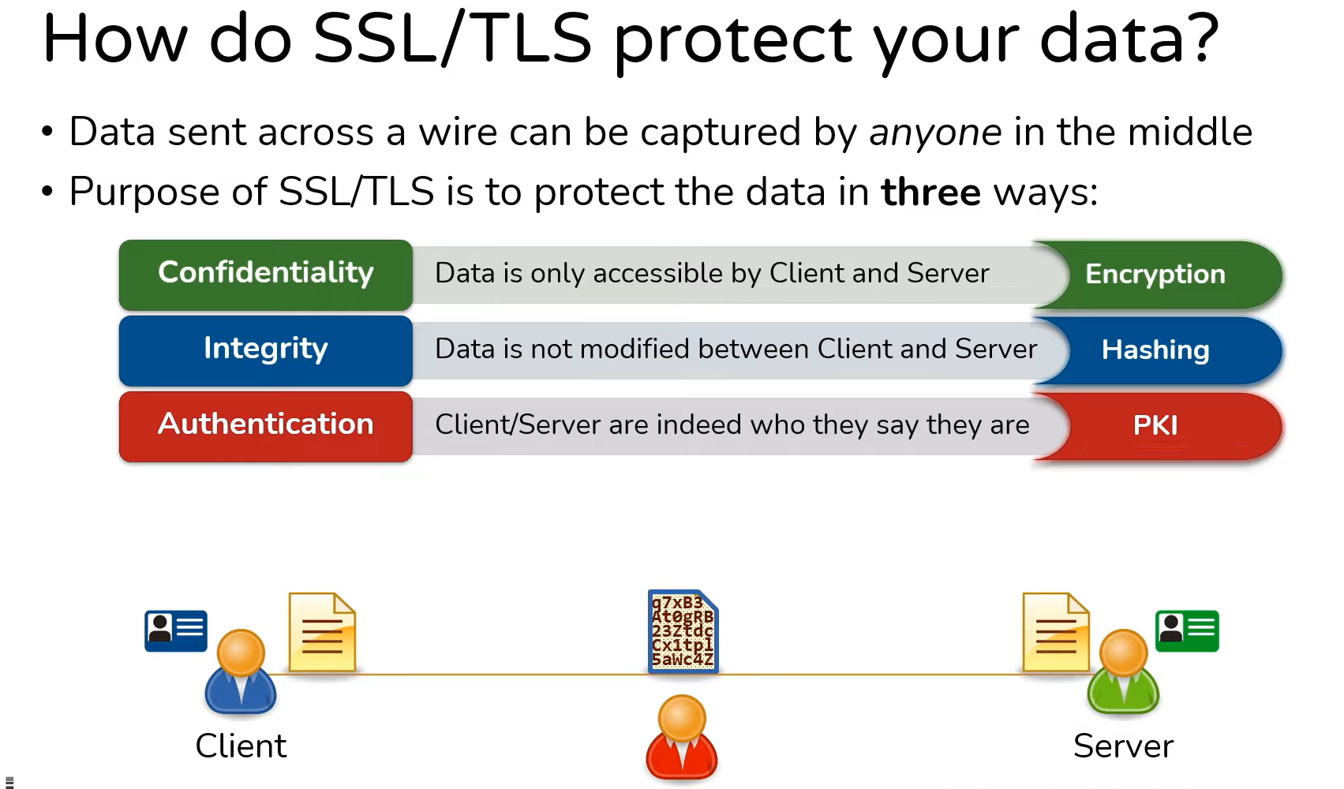

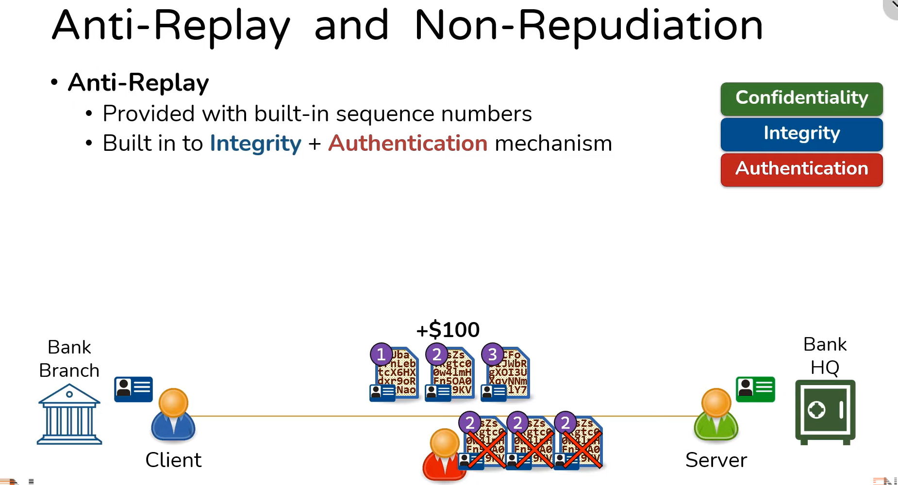

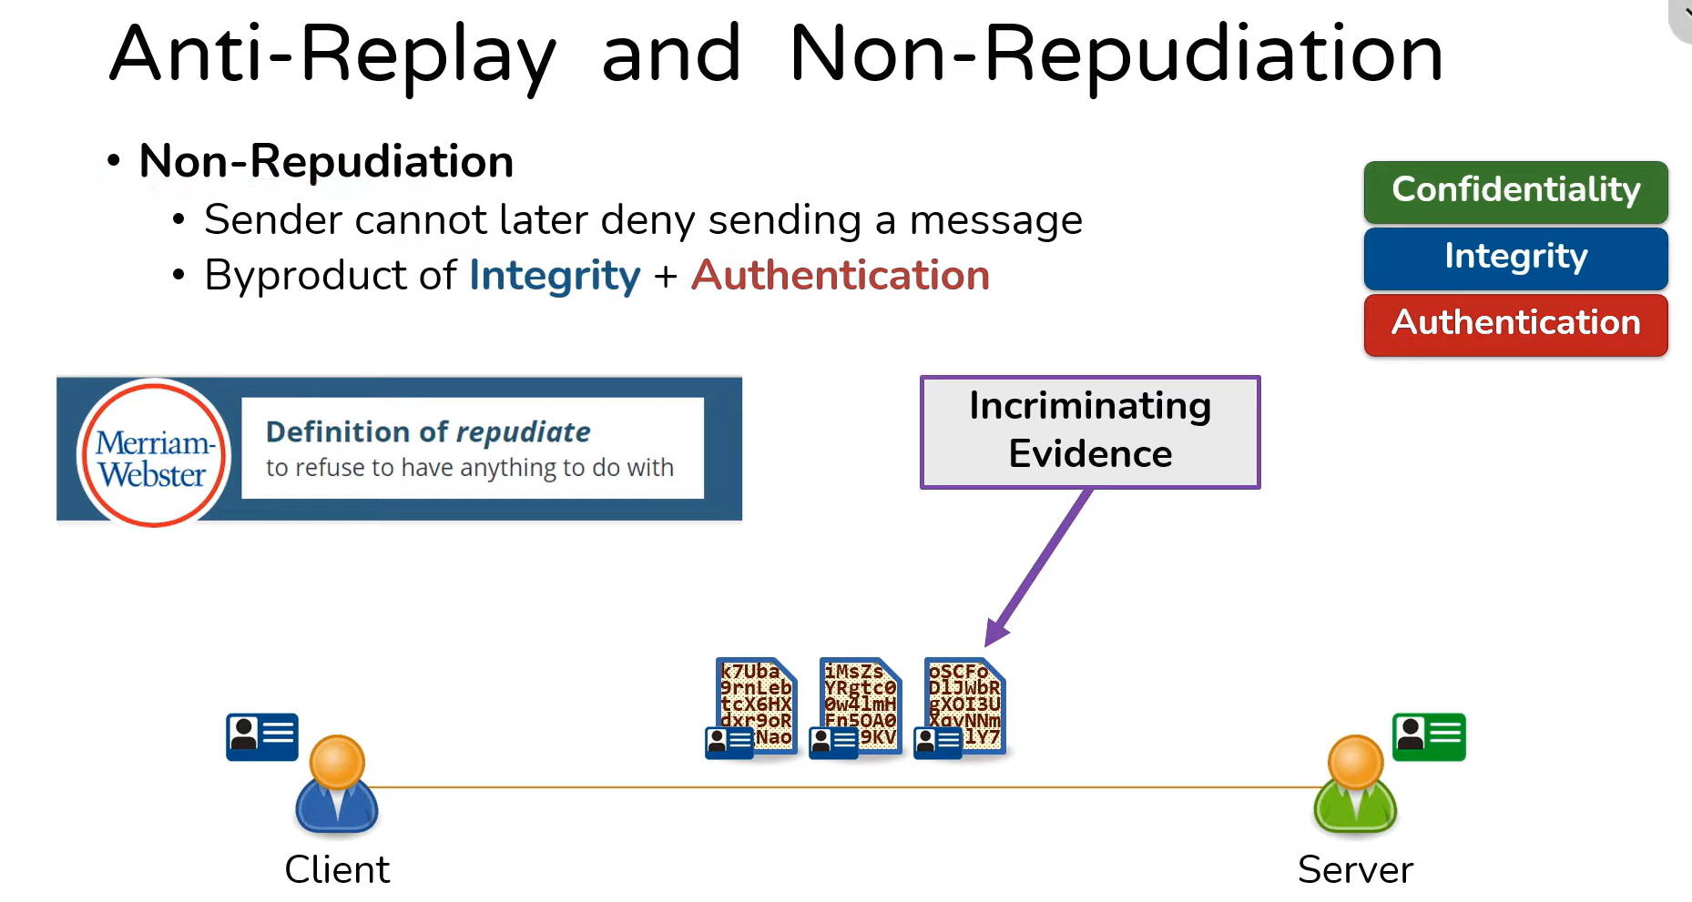

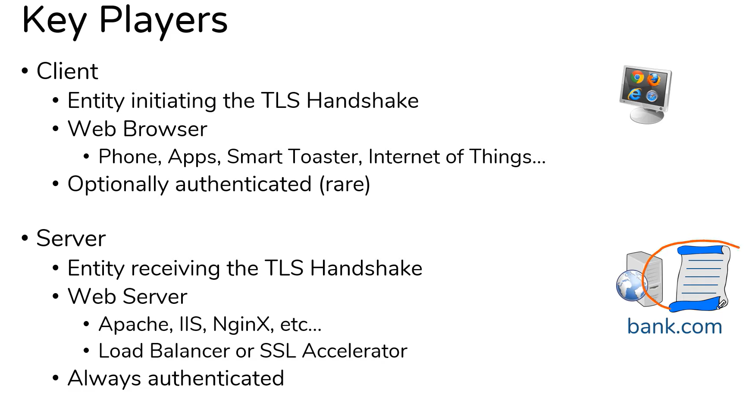

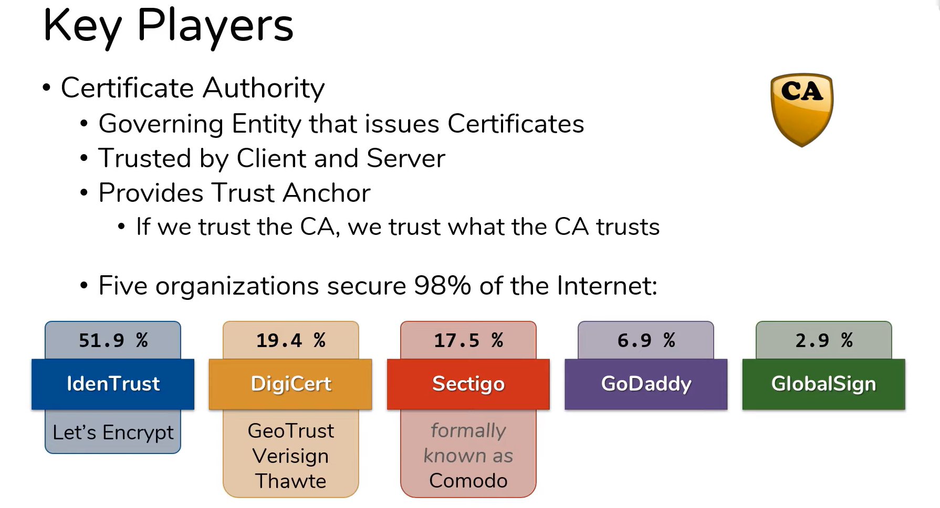

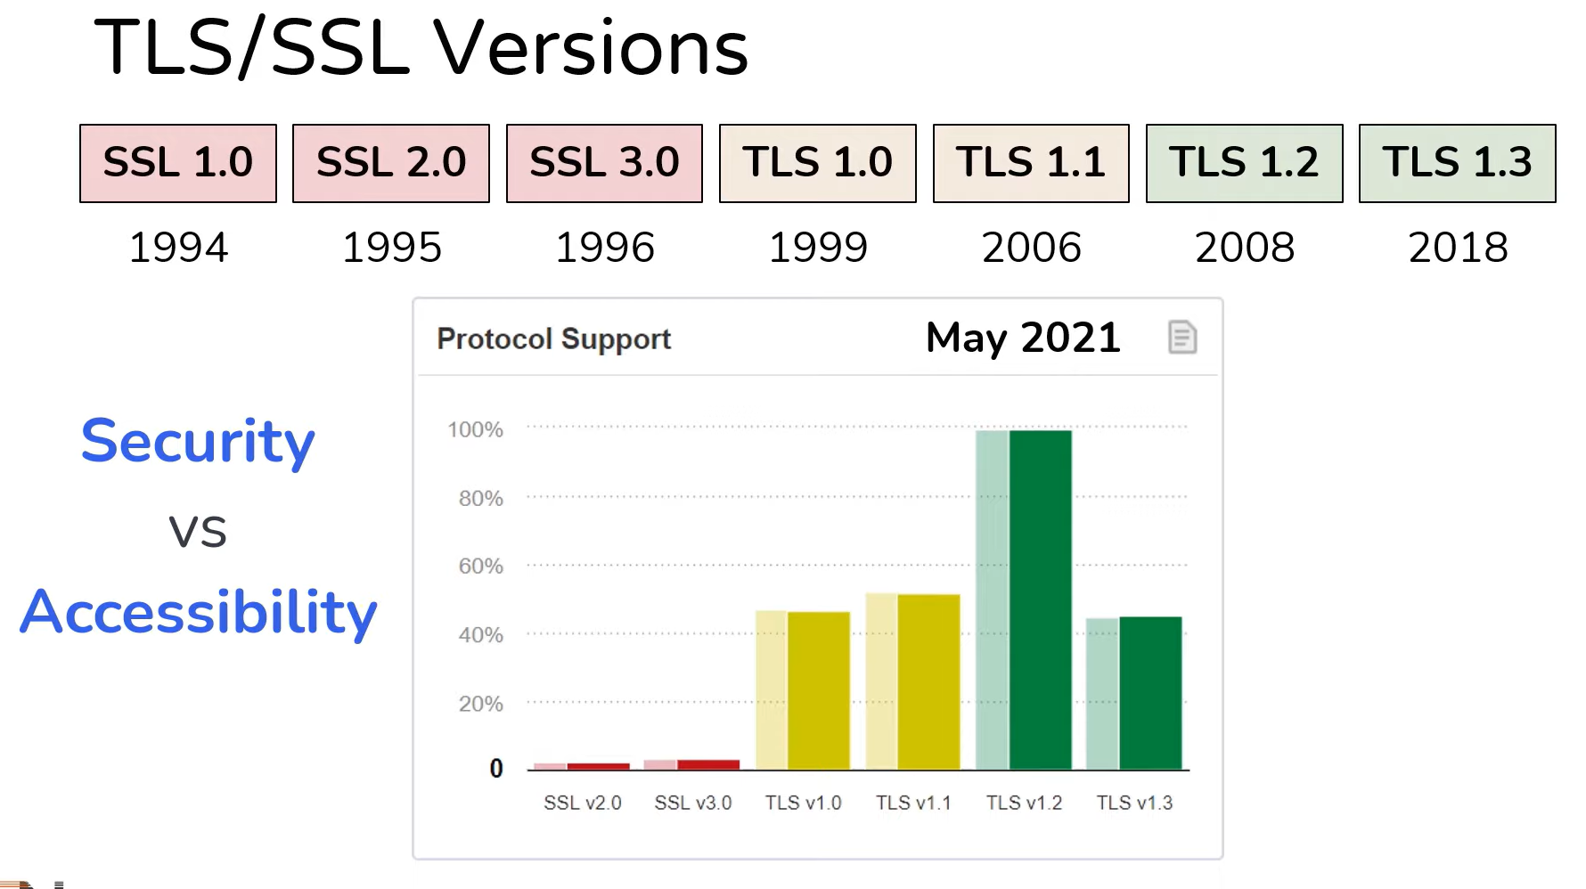

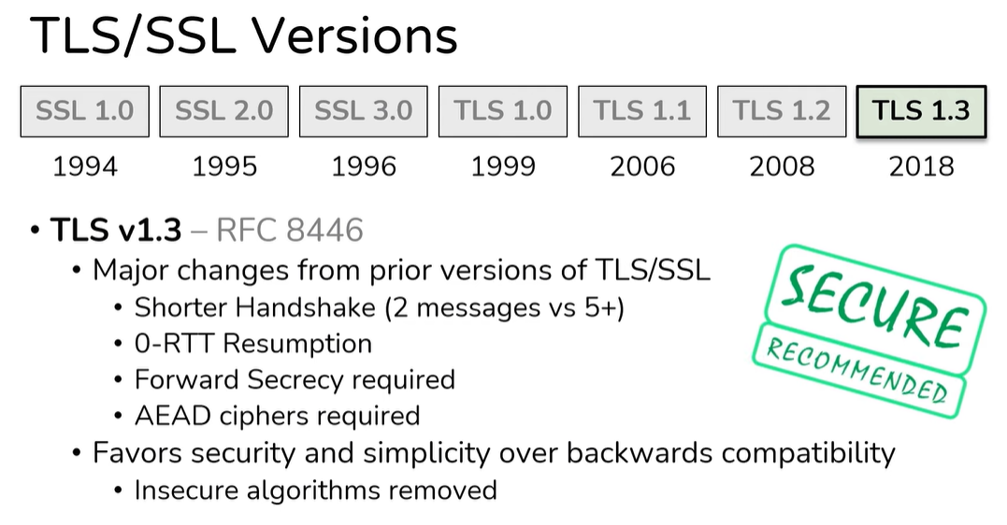

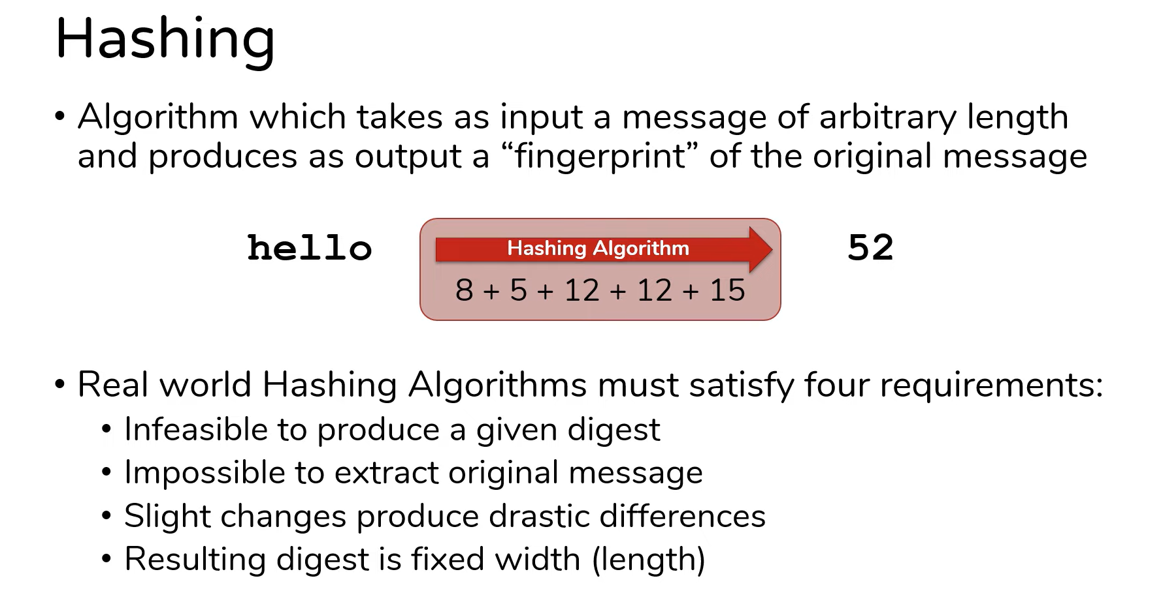

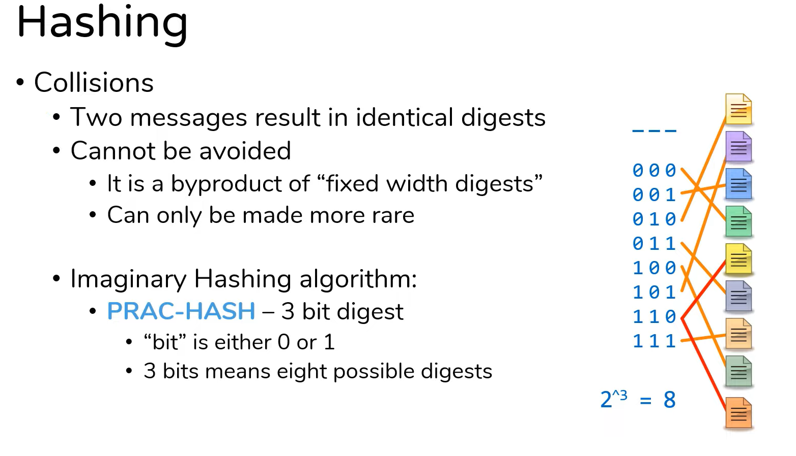

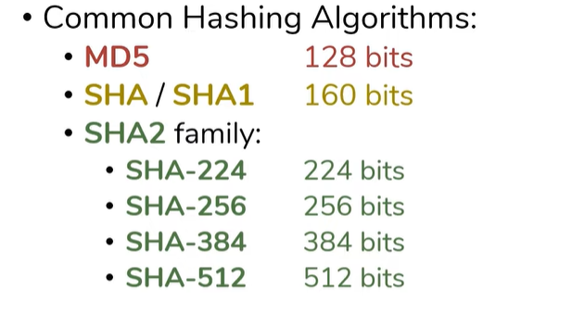

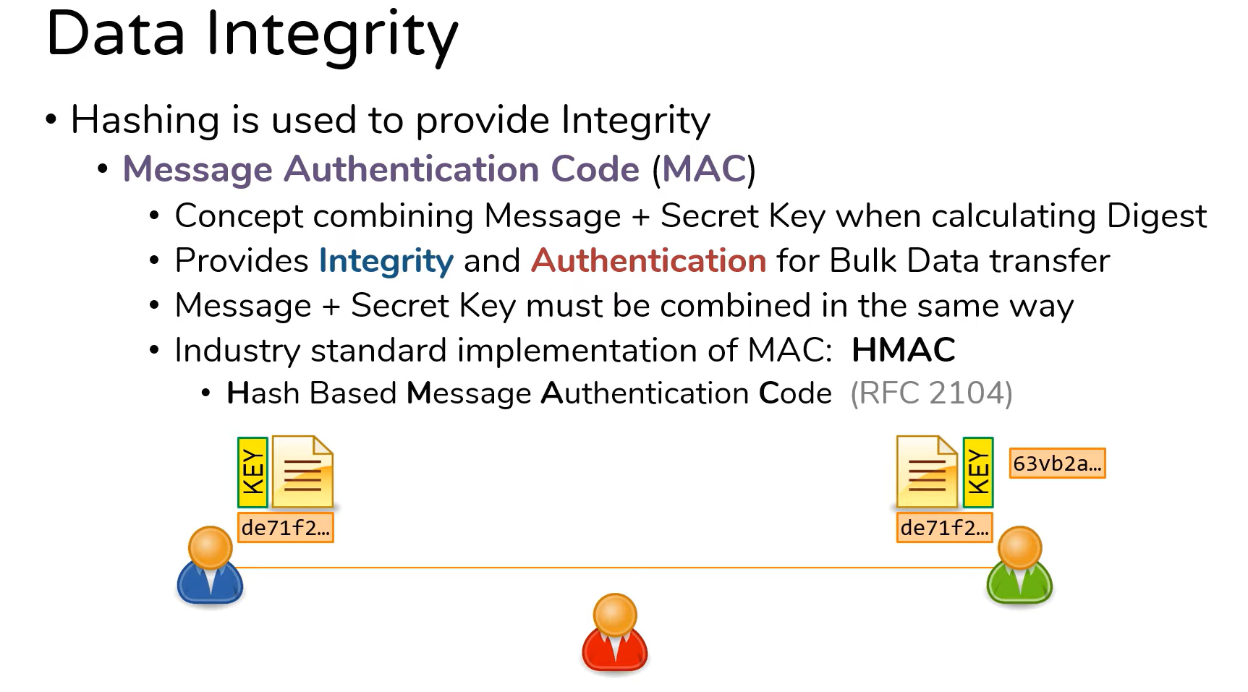

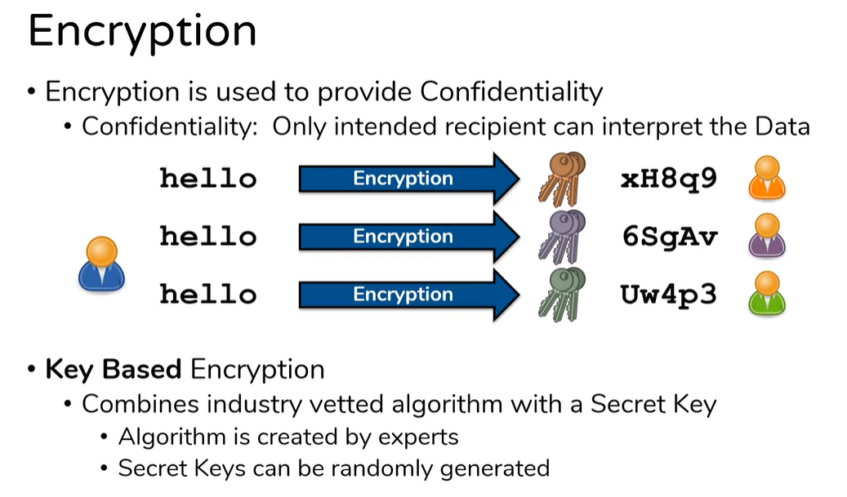

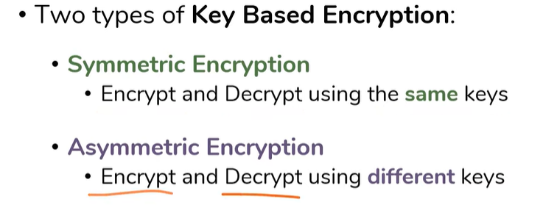

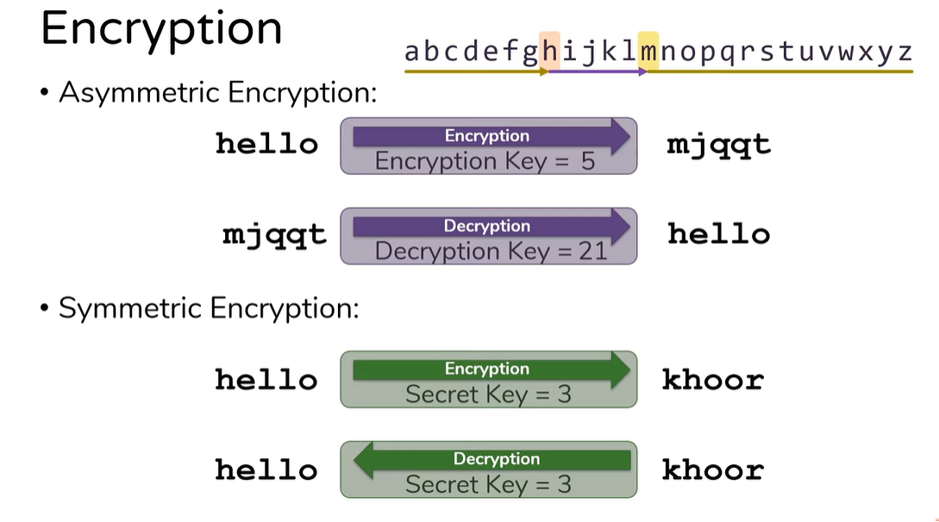

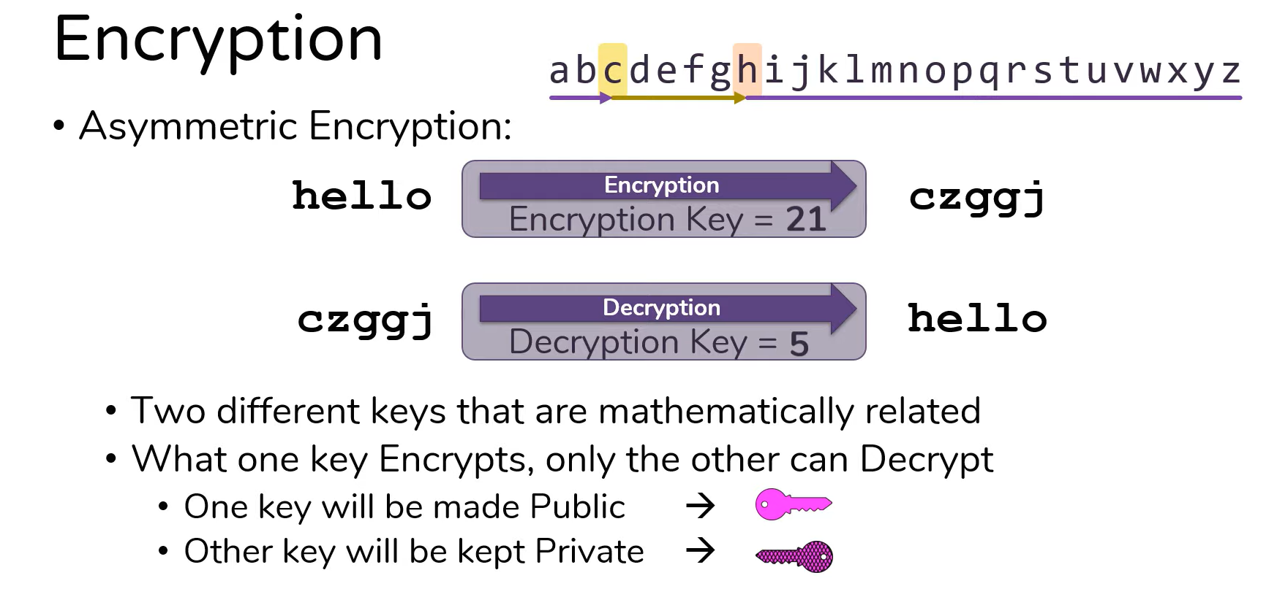

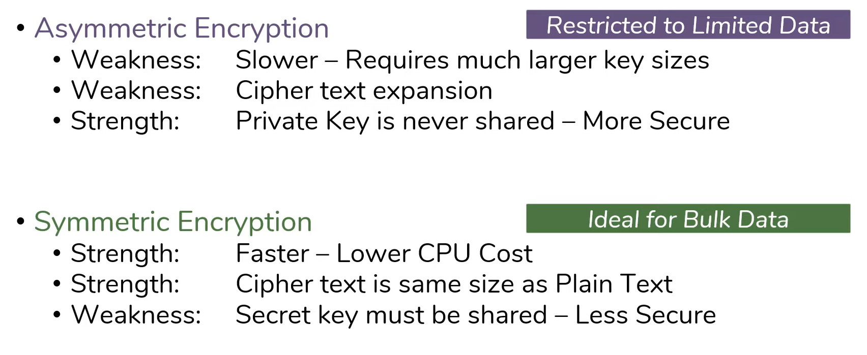

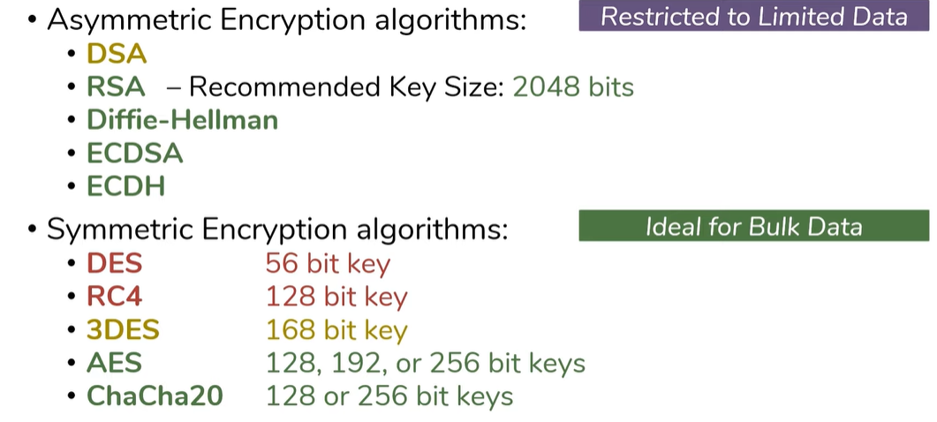

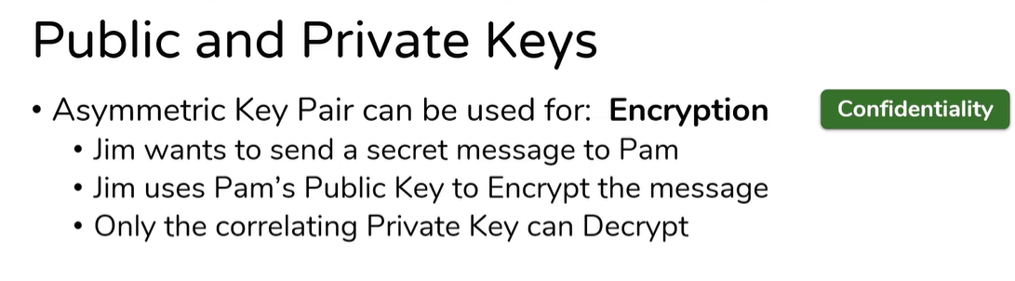

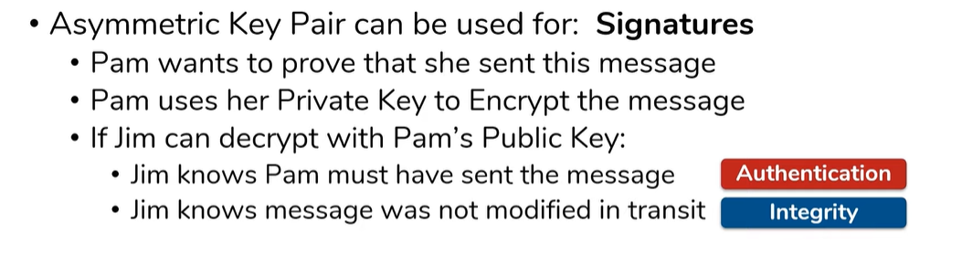

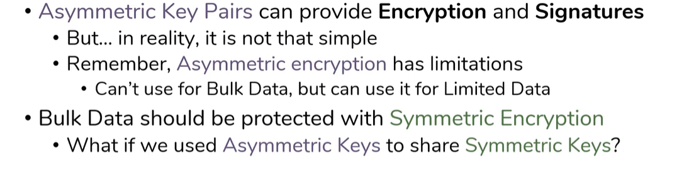

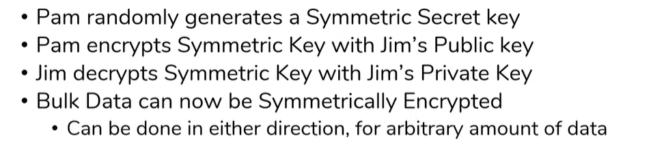

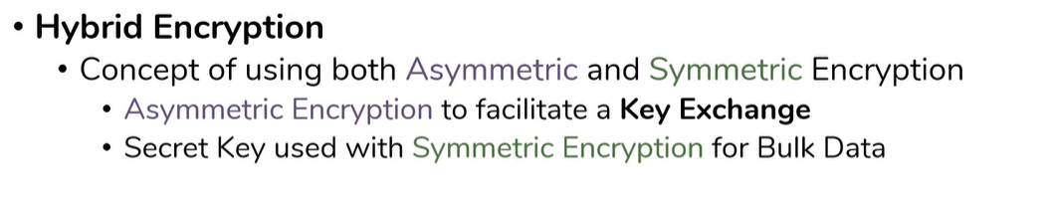

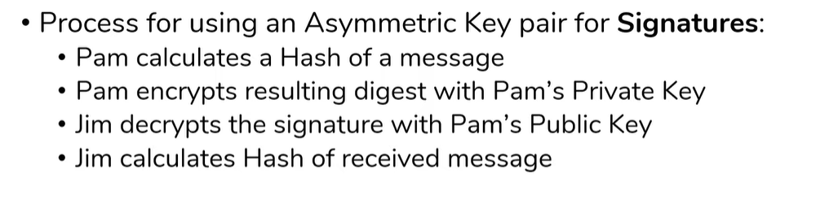

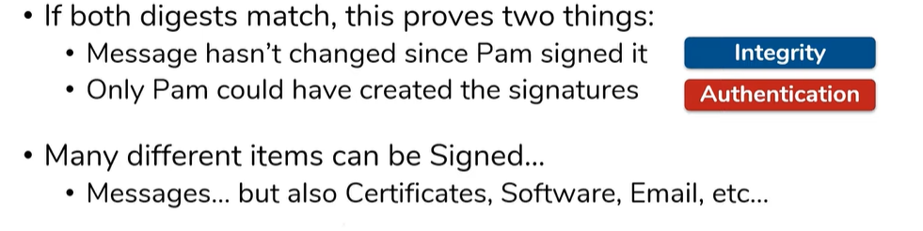

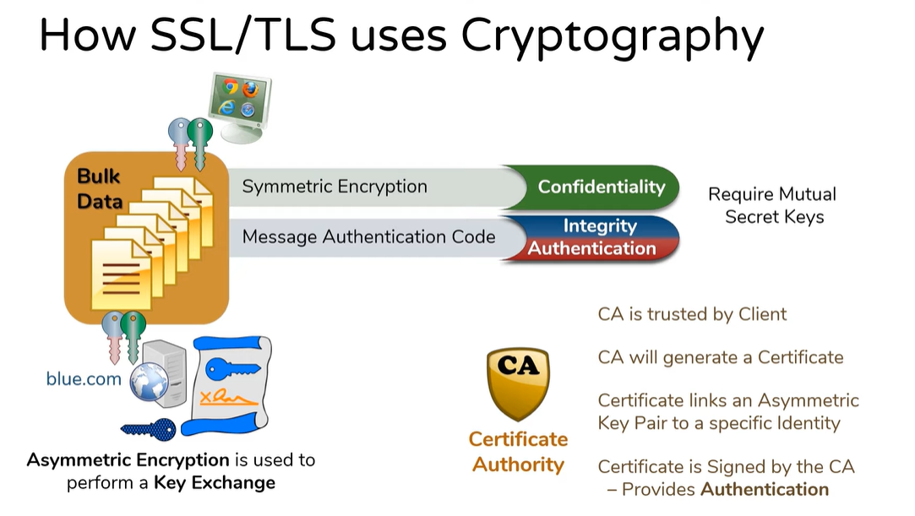

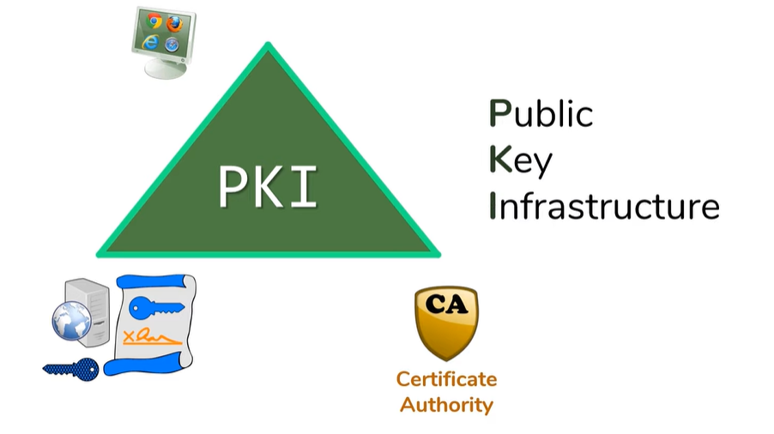

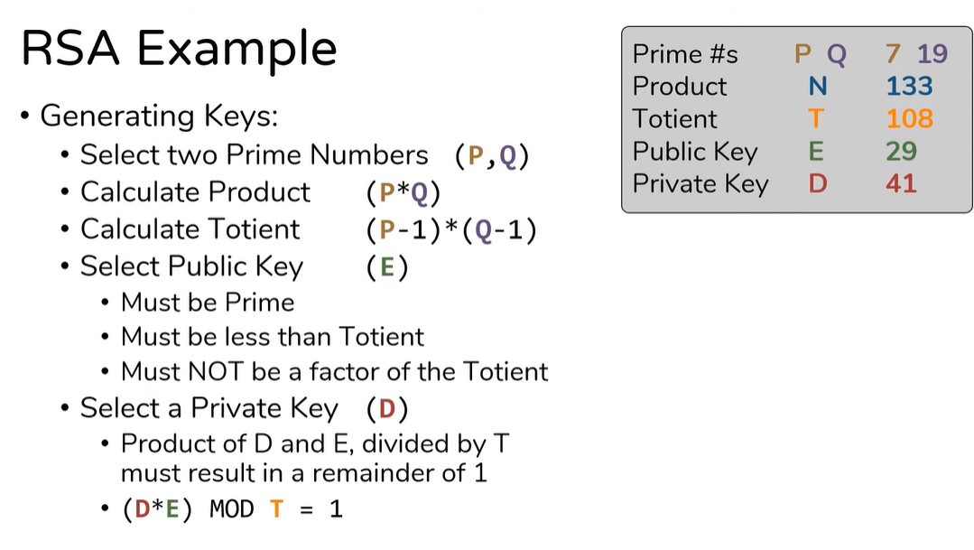

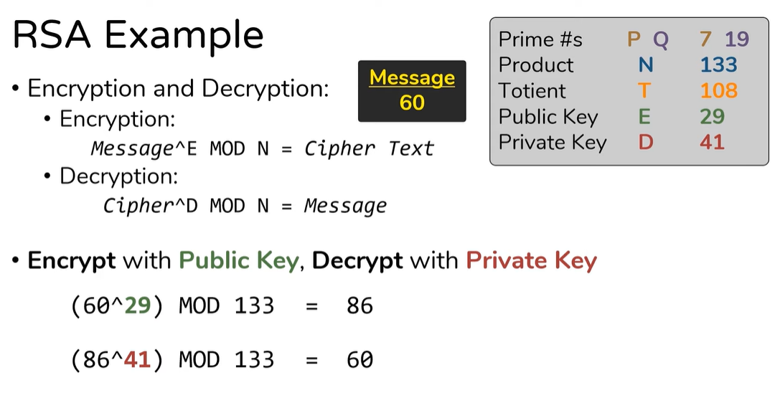

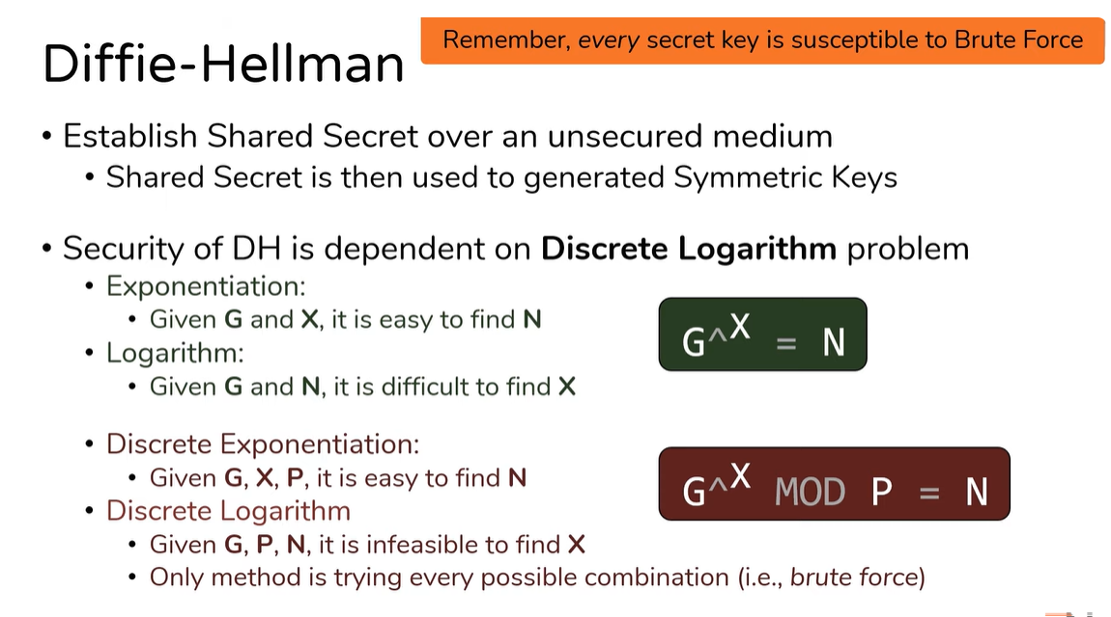

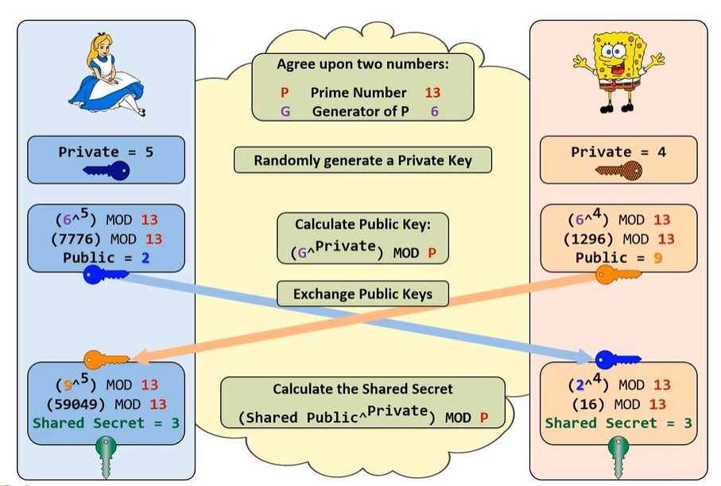

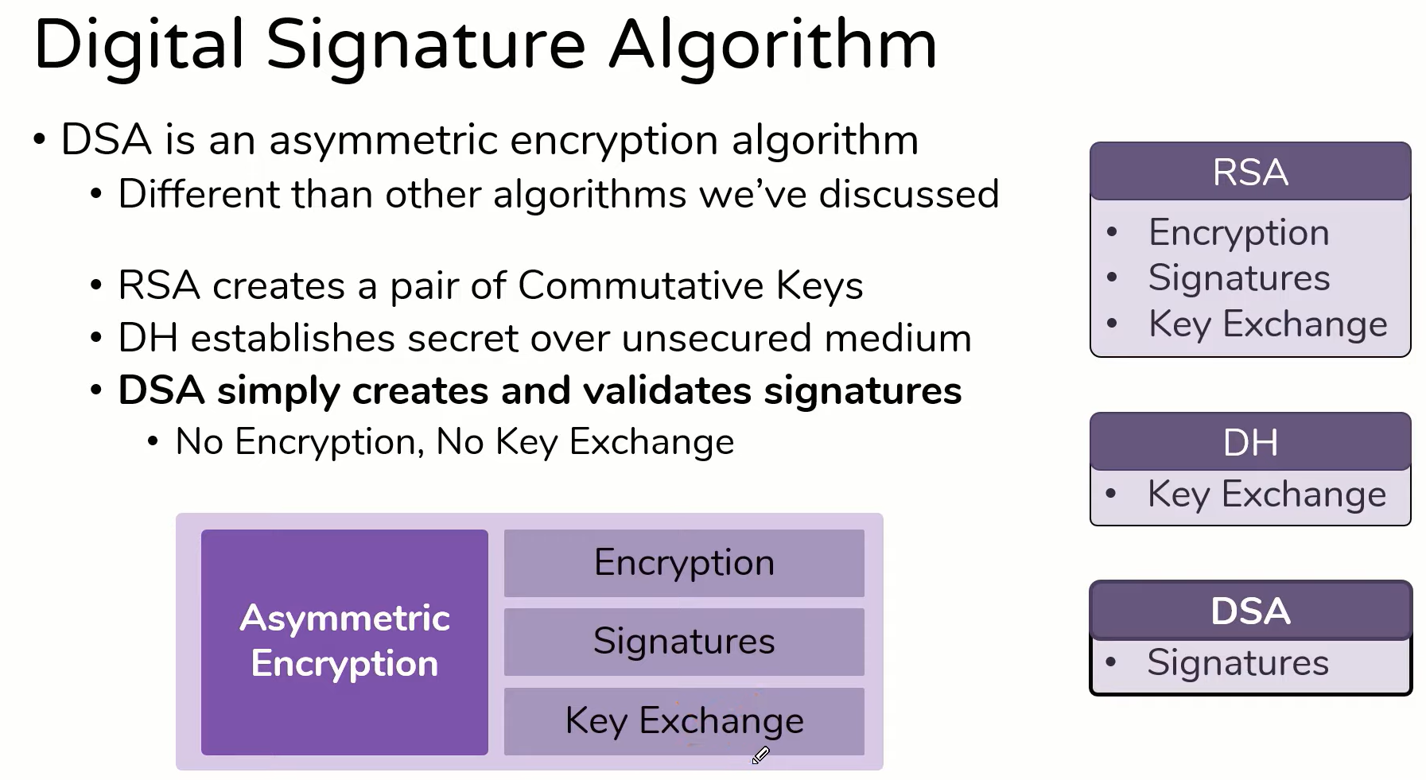

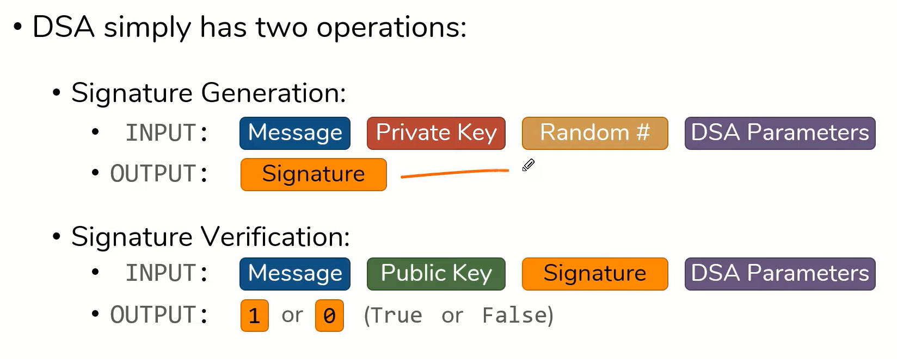

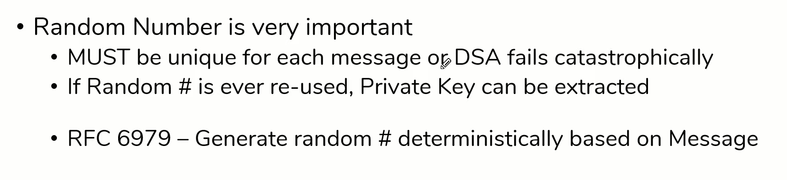

*TLS / SSL - The complete sequence*

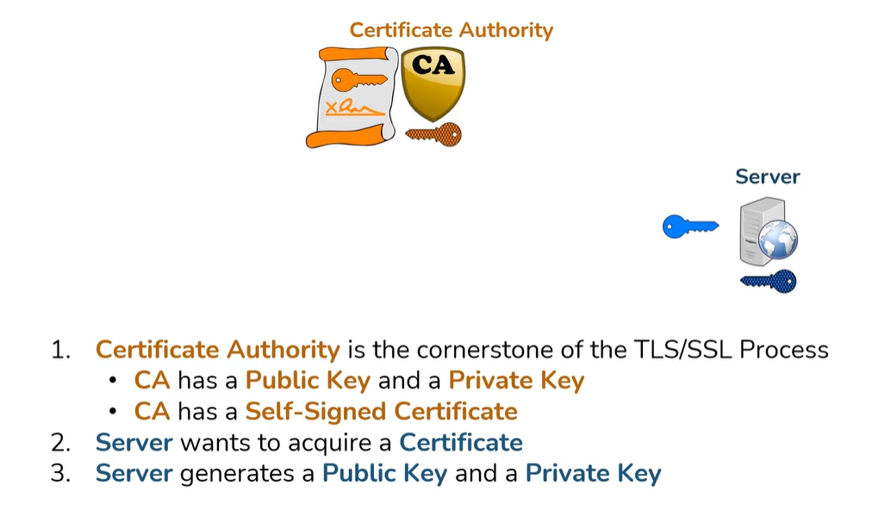0

